March 28 MASSIVE data document
- Run 9 – 51 degree angle. 11 positions spaced ~16um apart in l. OHC-DC region. Base-Apex as position increases. Pos 1: 26 kHz, Pos 11: 21.5 kHz
- BM and OHC within one run
Position 1 65 dB SPL
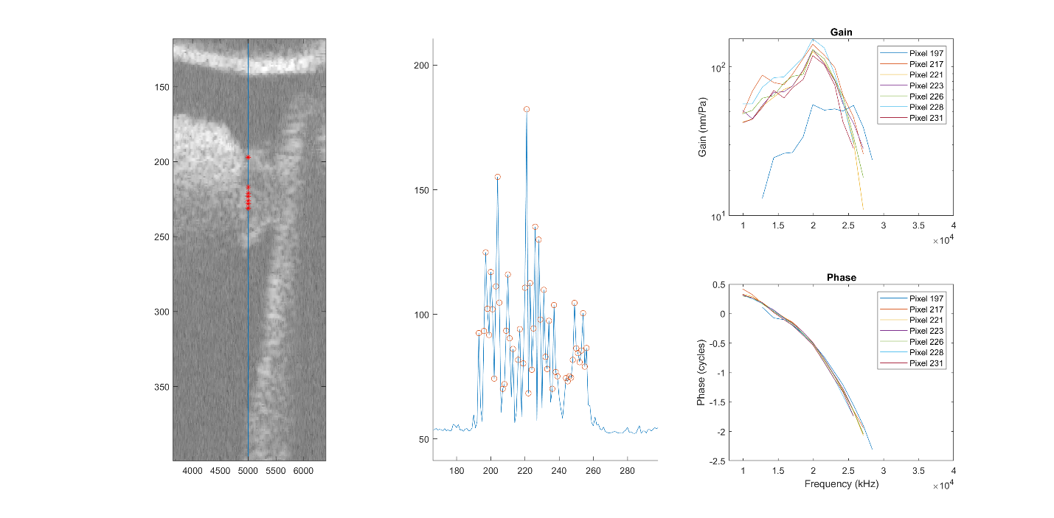
Can see that OHC re BM leads, then lags (changing ~0.8 BF) at 65 dB SPL within same run.
Position 1 80 dB SPL
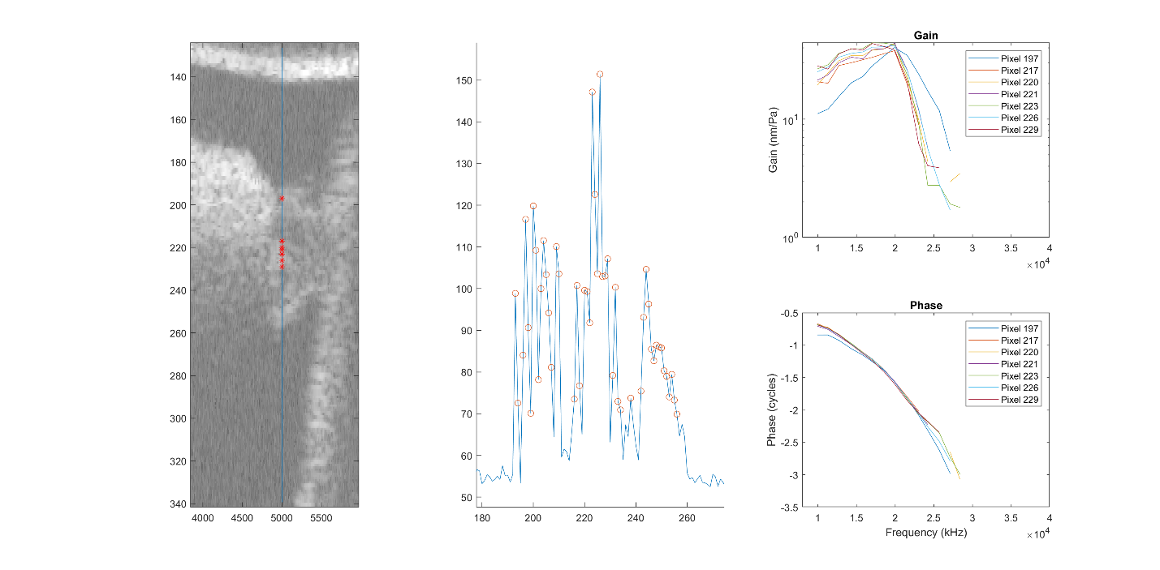
Quite different – OHC starts leading BM again as OHC response “flattens out
Position 2 50 dB
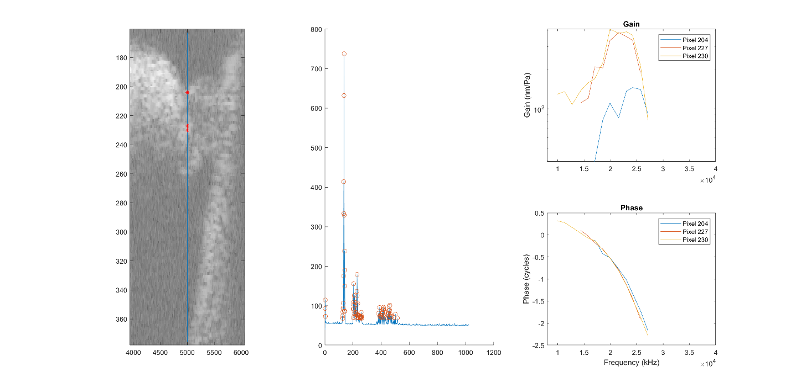
No low-frequency BM data, but OHC lags BM above ~0.8 BF
Position 2 65 dB
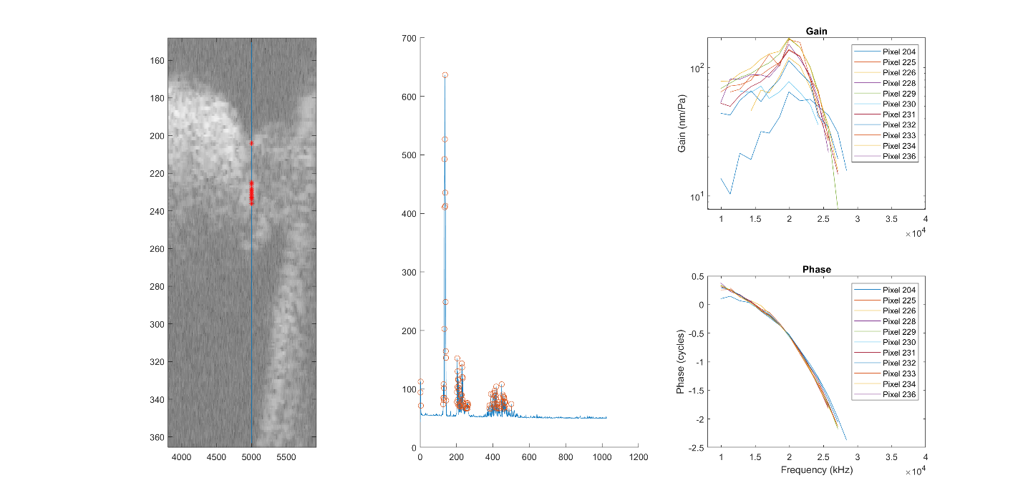
Lots of good data, which is cool. All OHC points Lead->lag crossover at ~0.8BF
Position 2 80 dB
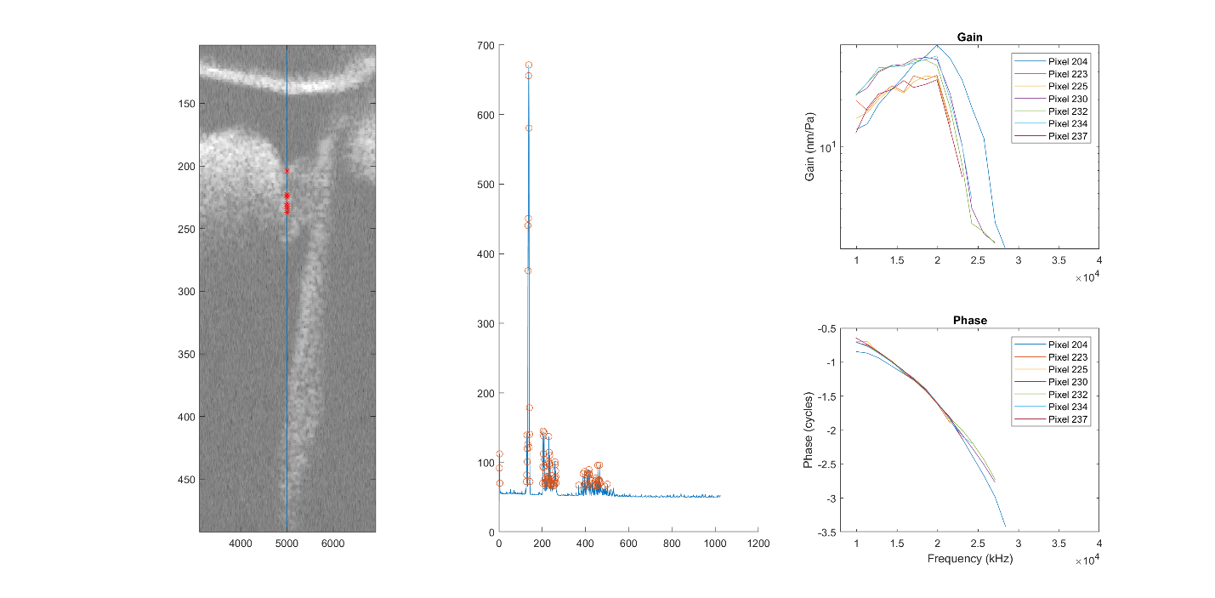
Again, here OHC leads until ~0.8BF, then the lead increases at higher frequencies rather than transitioning to a lag.
Position 11 50-80dB
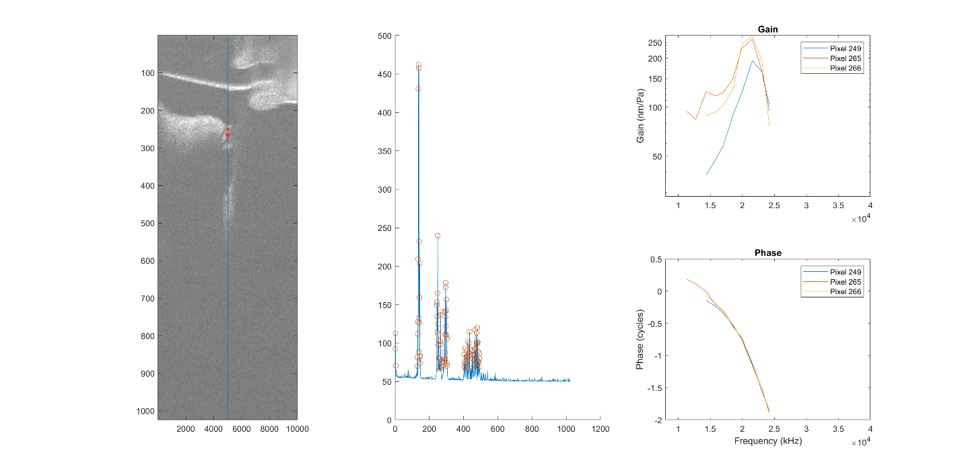
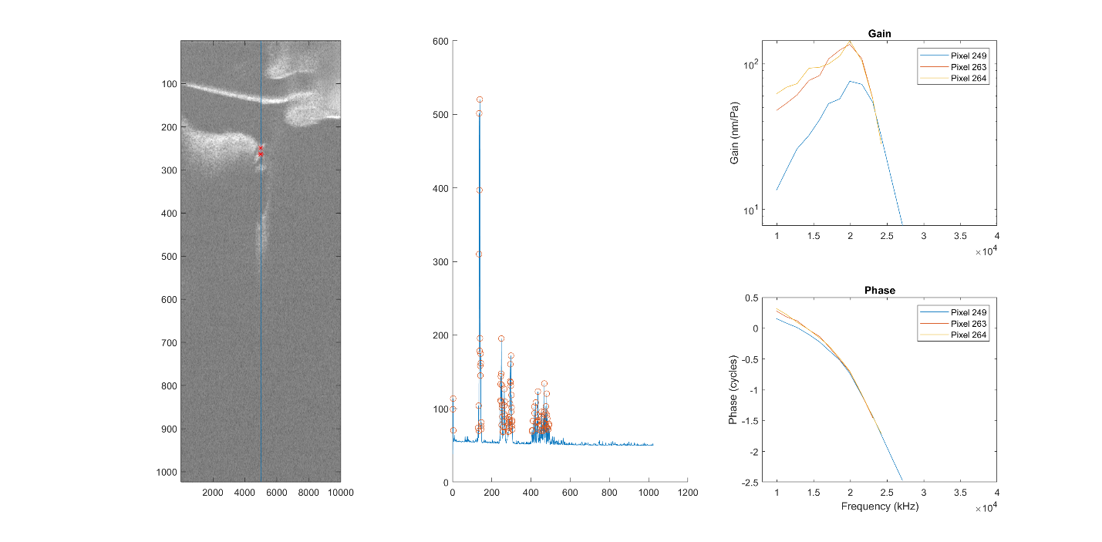
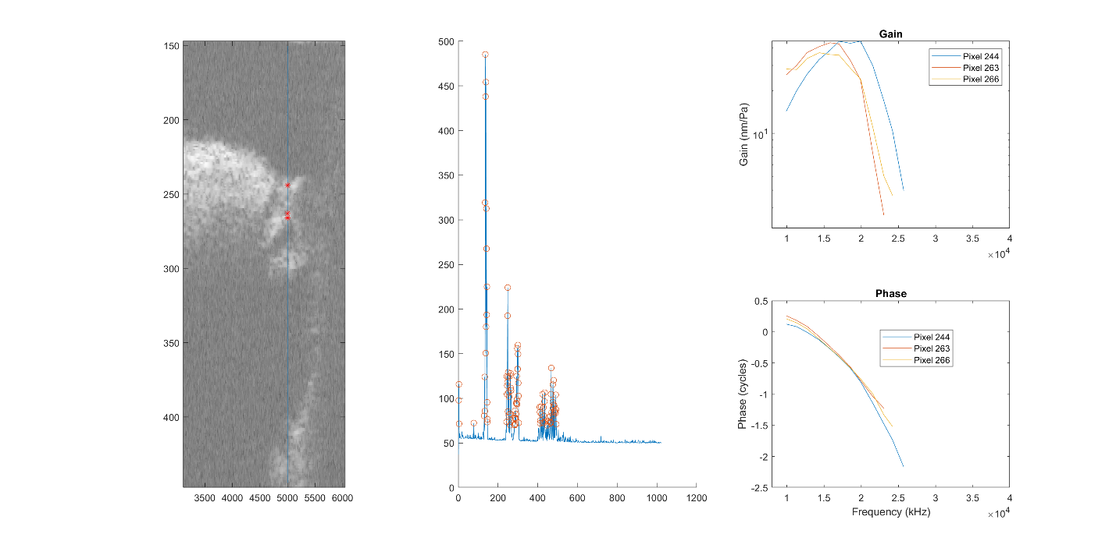
So here we see similar things except that we don’t see the transition to lag in 50-65dB, but also don’t see high-frequency data. Believe me that the pattern exists in positions 3-10.
- BM and OHC within one cross-section, or “aligned” (OHC BLUE, BM RED)
Position 1 50 dB
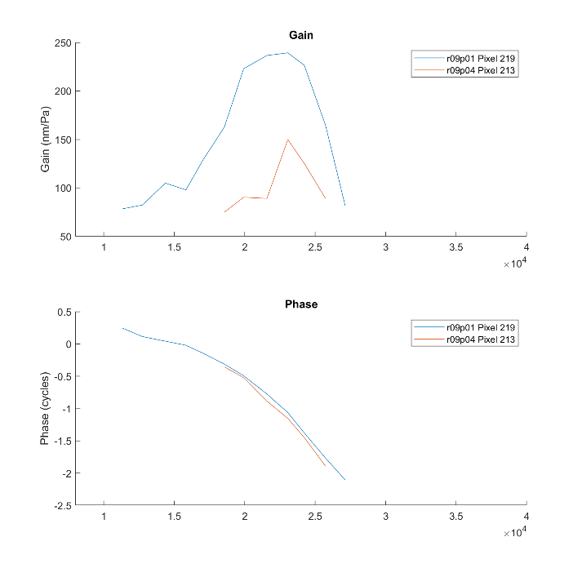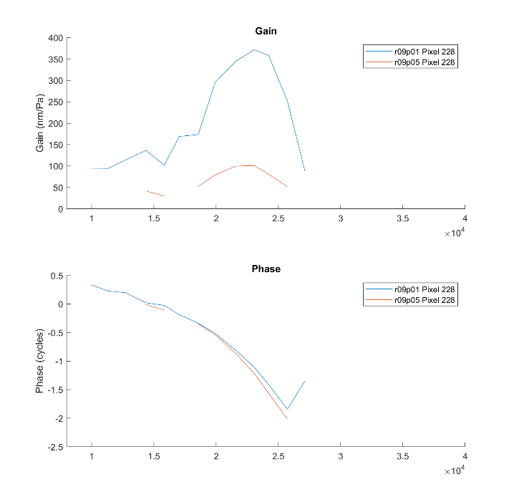
Two places in the OHC region in position 1, different cross-sections. Looks like within one cross-section at 50dB, OHC leads BM above 0.8BF. Opposite of what we saw in one measurement. No low-frequency BM data, sadly.
Position 1 65 dB
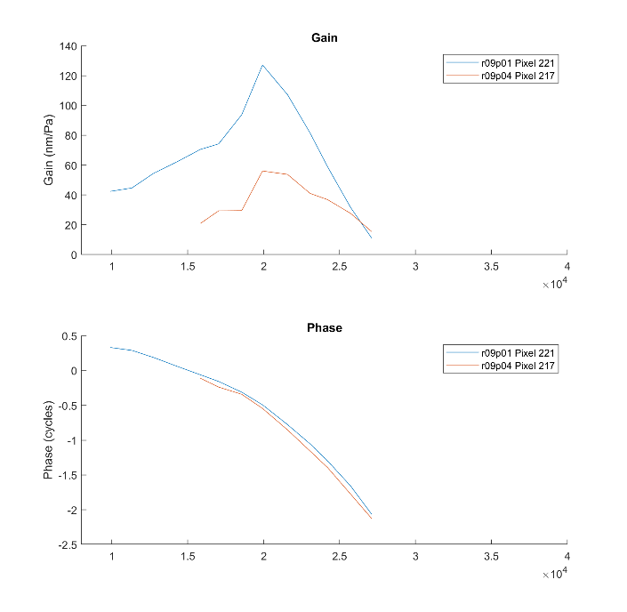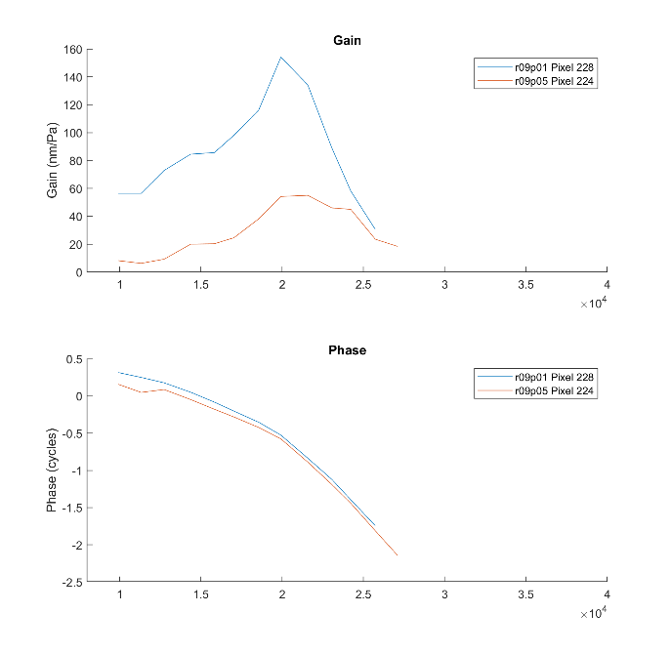
Here at 65 dB OHC seems to lead BM across frequency with the largest lead being at low frequencies.
Position 1 80 dB
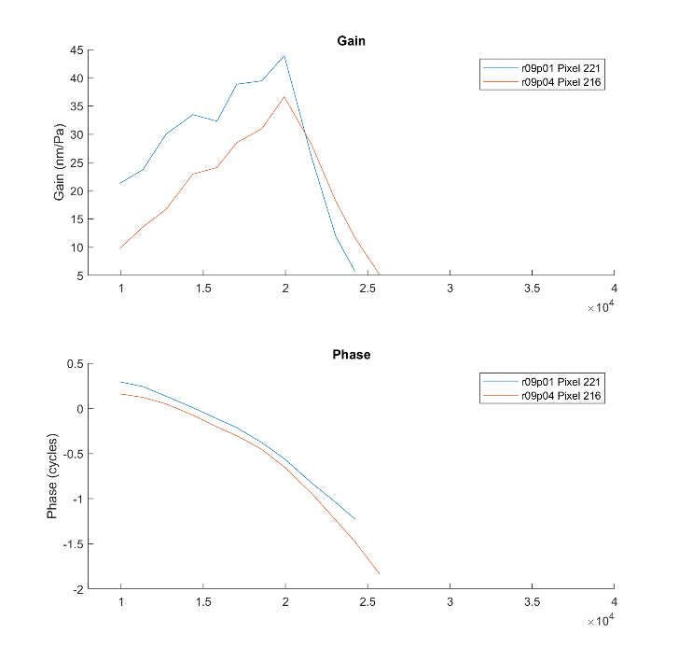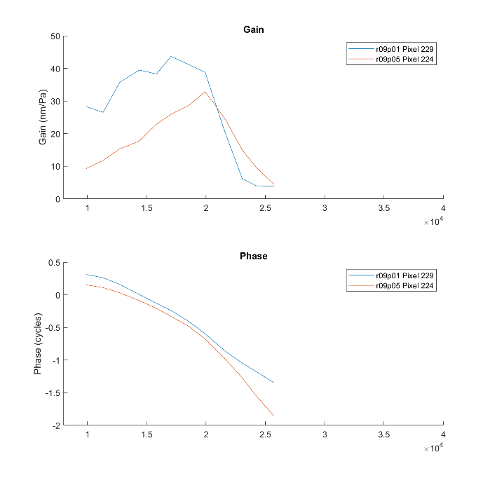
At 80 dB SPL we see the OHCs lead BM across all frequency, with the lead being much more (especially at high frequency) than what was seen at 50 and 65 dB SPL
Position 7 50 dB
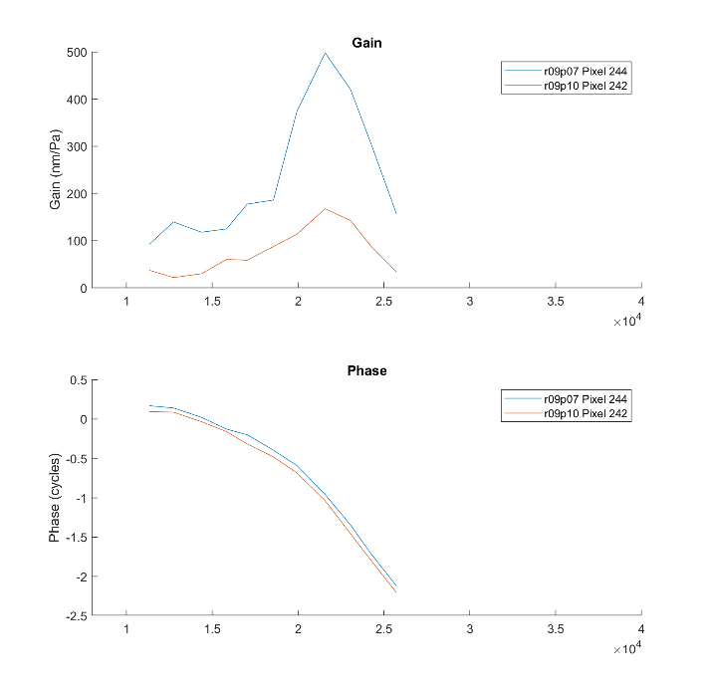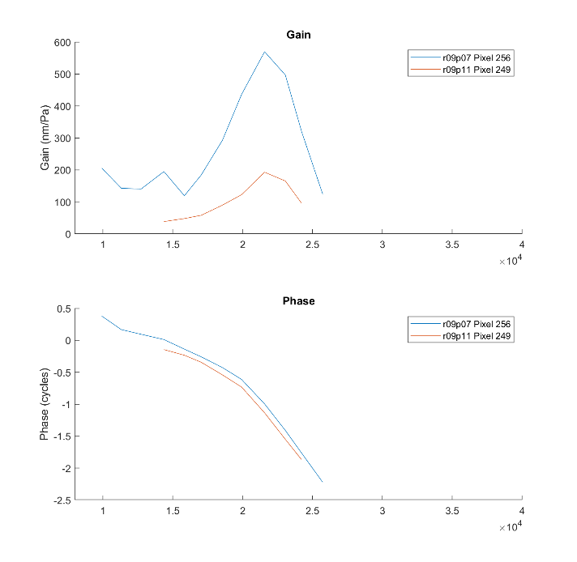

Position 7 65 dB
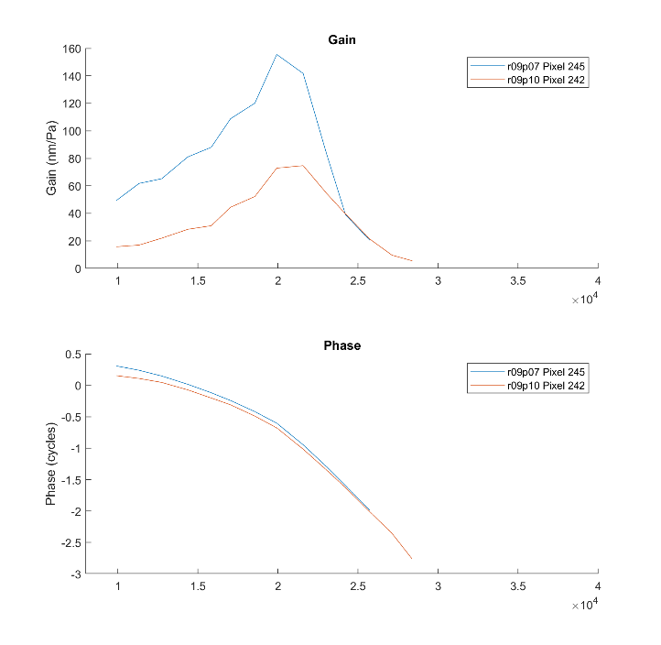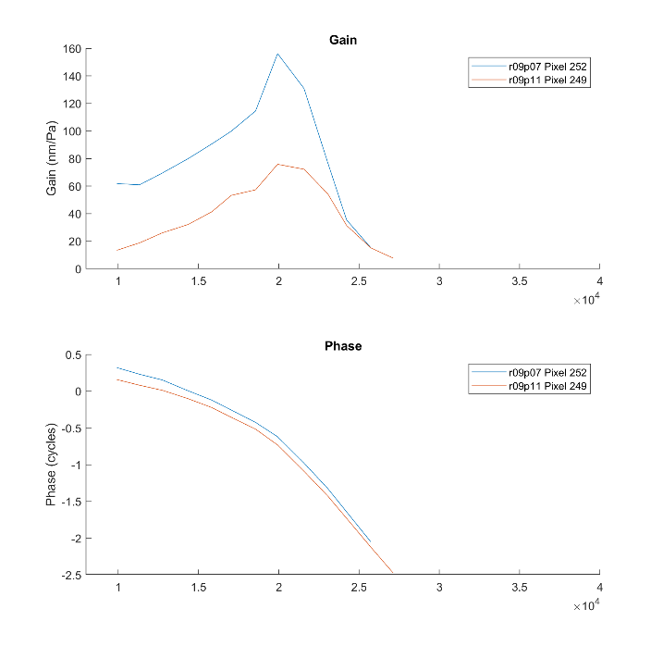
Position 7 80 dB
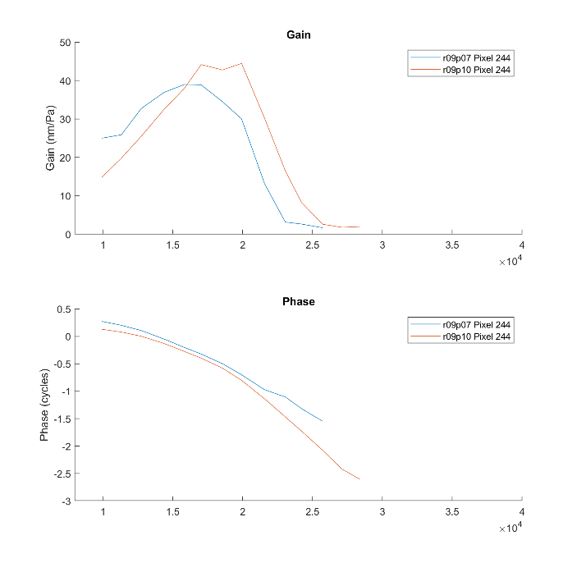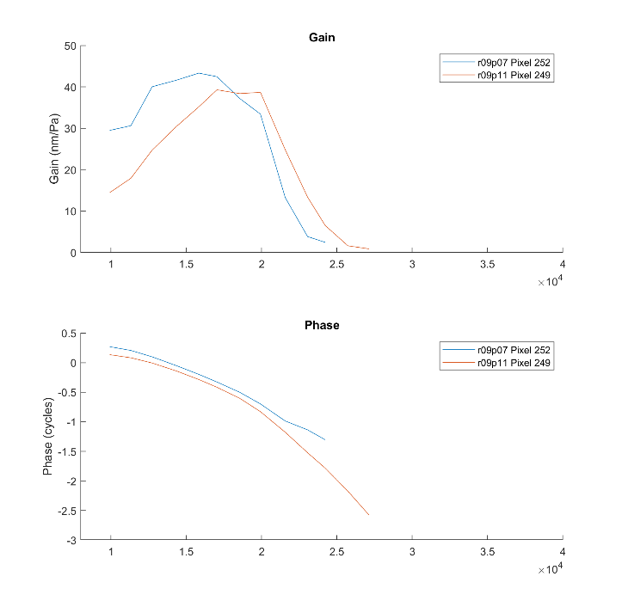
These show that the pattern continues at other locations.
And now, on the same curve (OHC blue furtherr BM, OHC yellow nearer to BM, BM red)
The “far-from-BM” OHC point is still at the base of the OHC/middle of OHC, not RL. It is 4 positions away from its aligned BM (64um away longitudinally). The near-BM OHC is at the OHC base and is 3 positions away (48um). At all SPL and all positions measured, the two OHC regions seem very much aligned in phase. Here’s a dump:

Position 1 50, 65, 80 dB
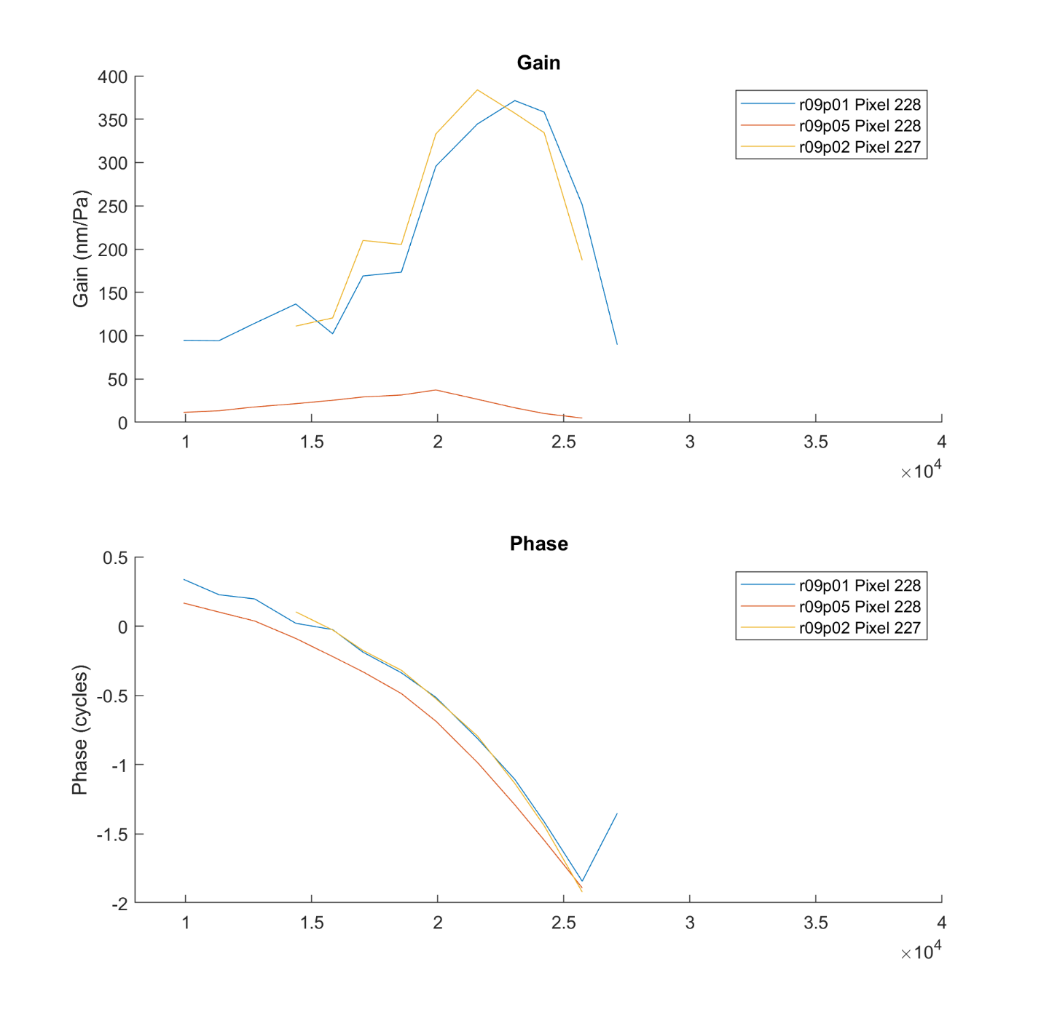
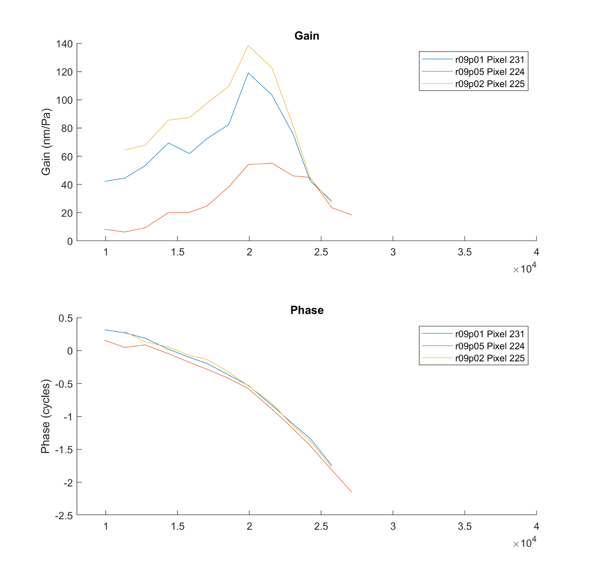
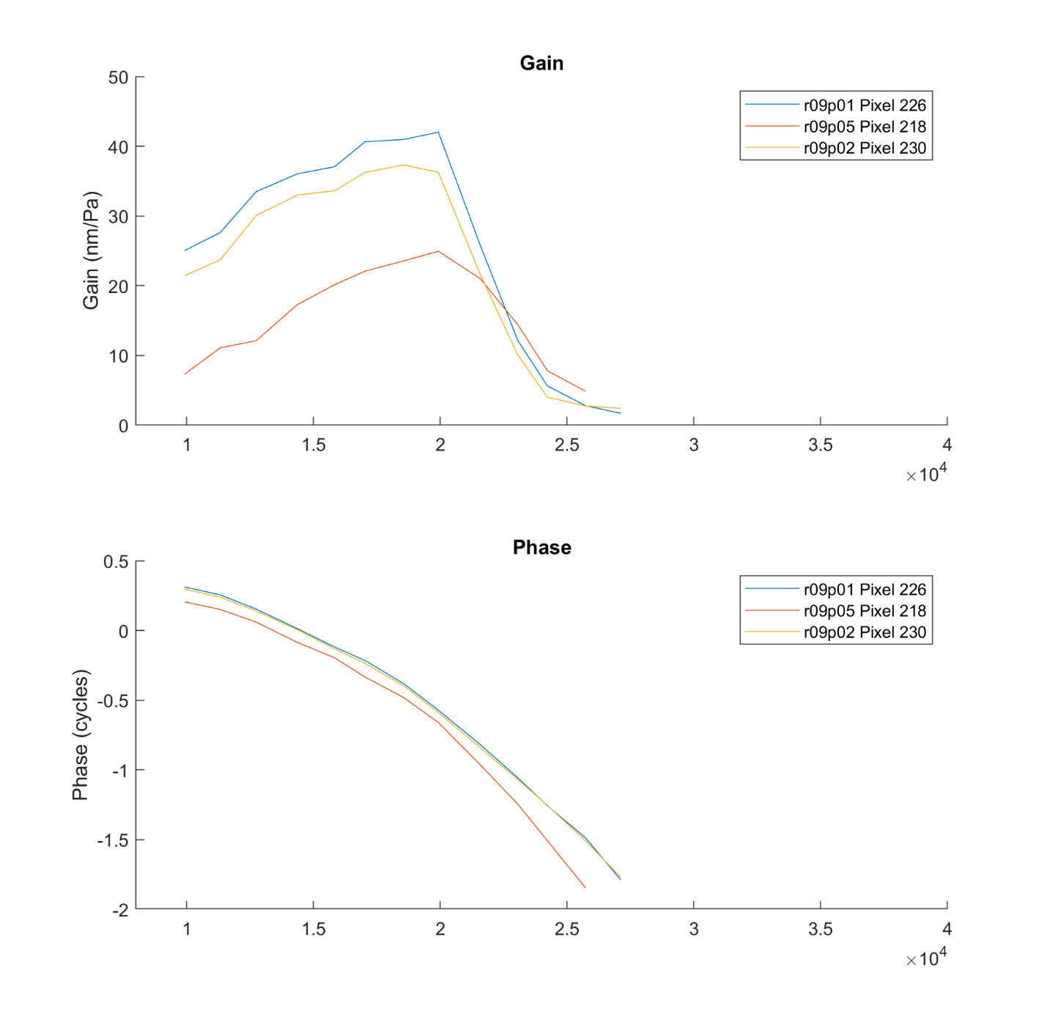
Position 7, 50, 65, 80 dB SPL
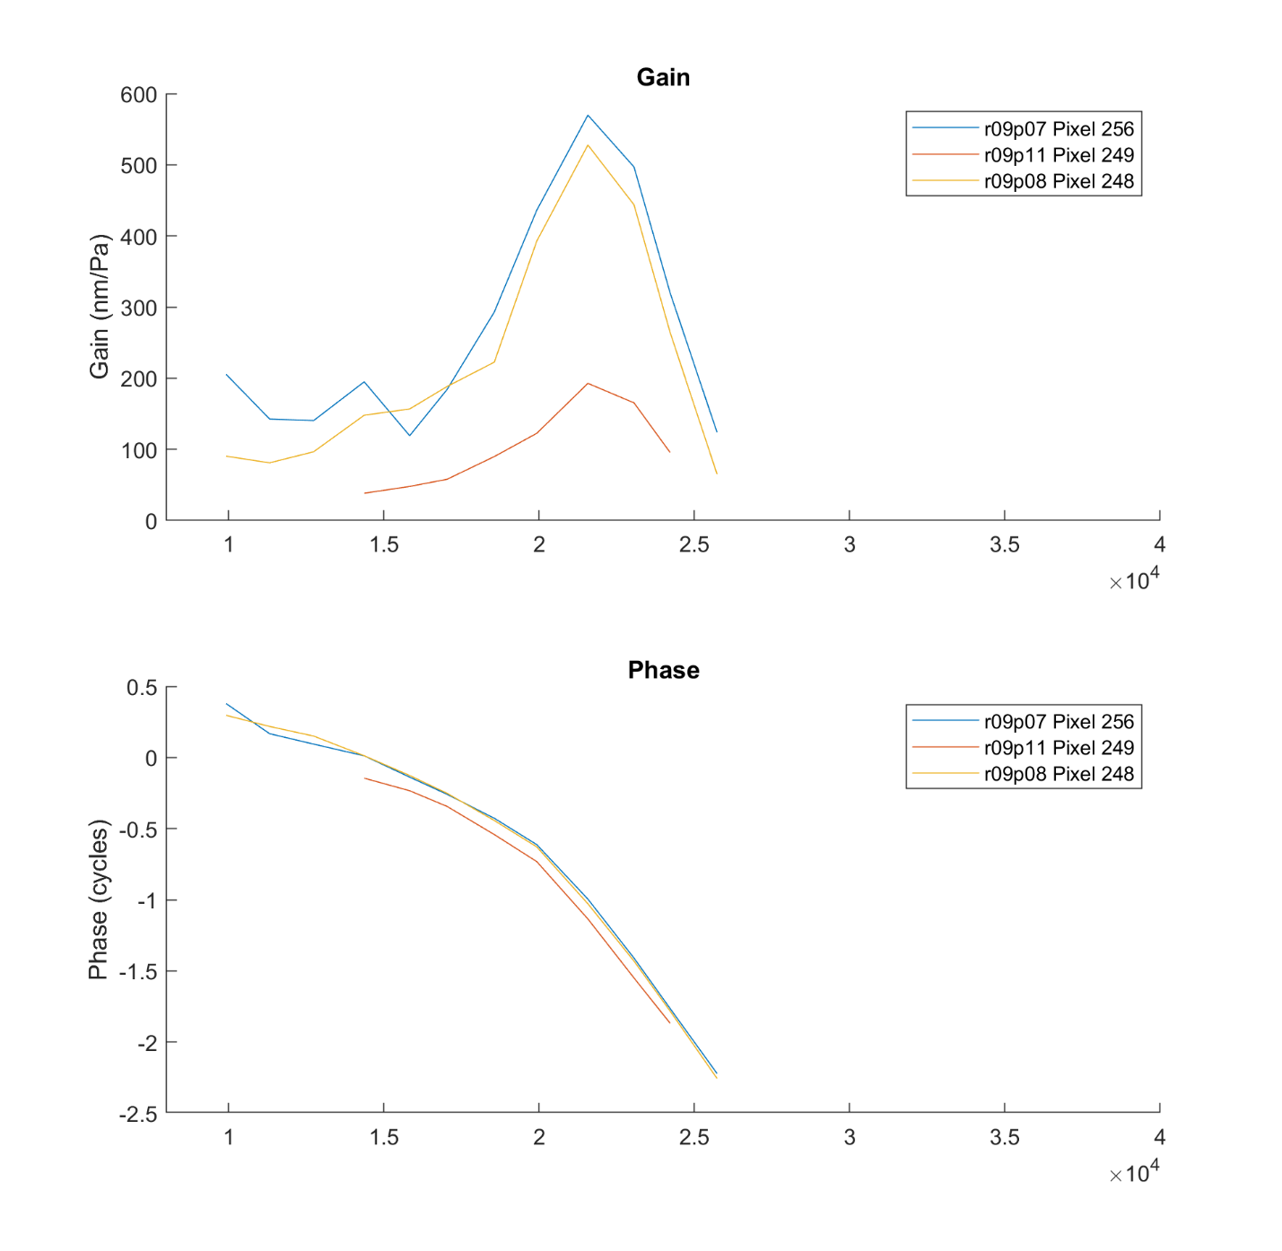
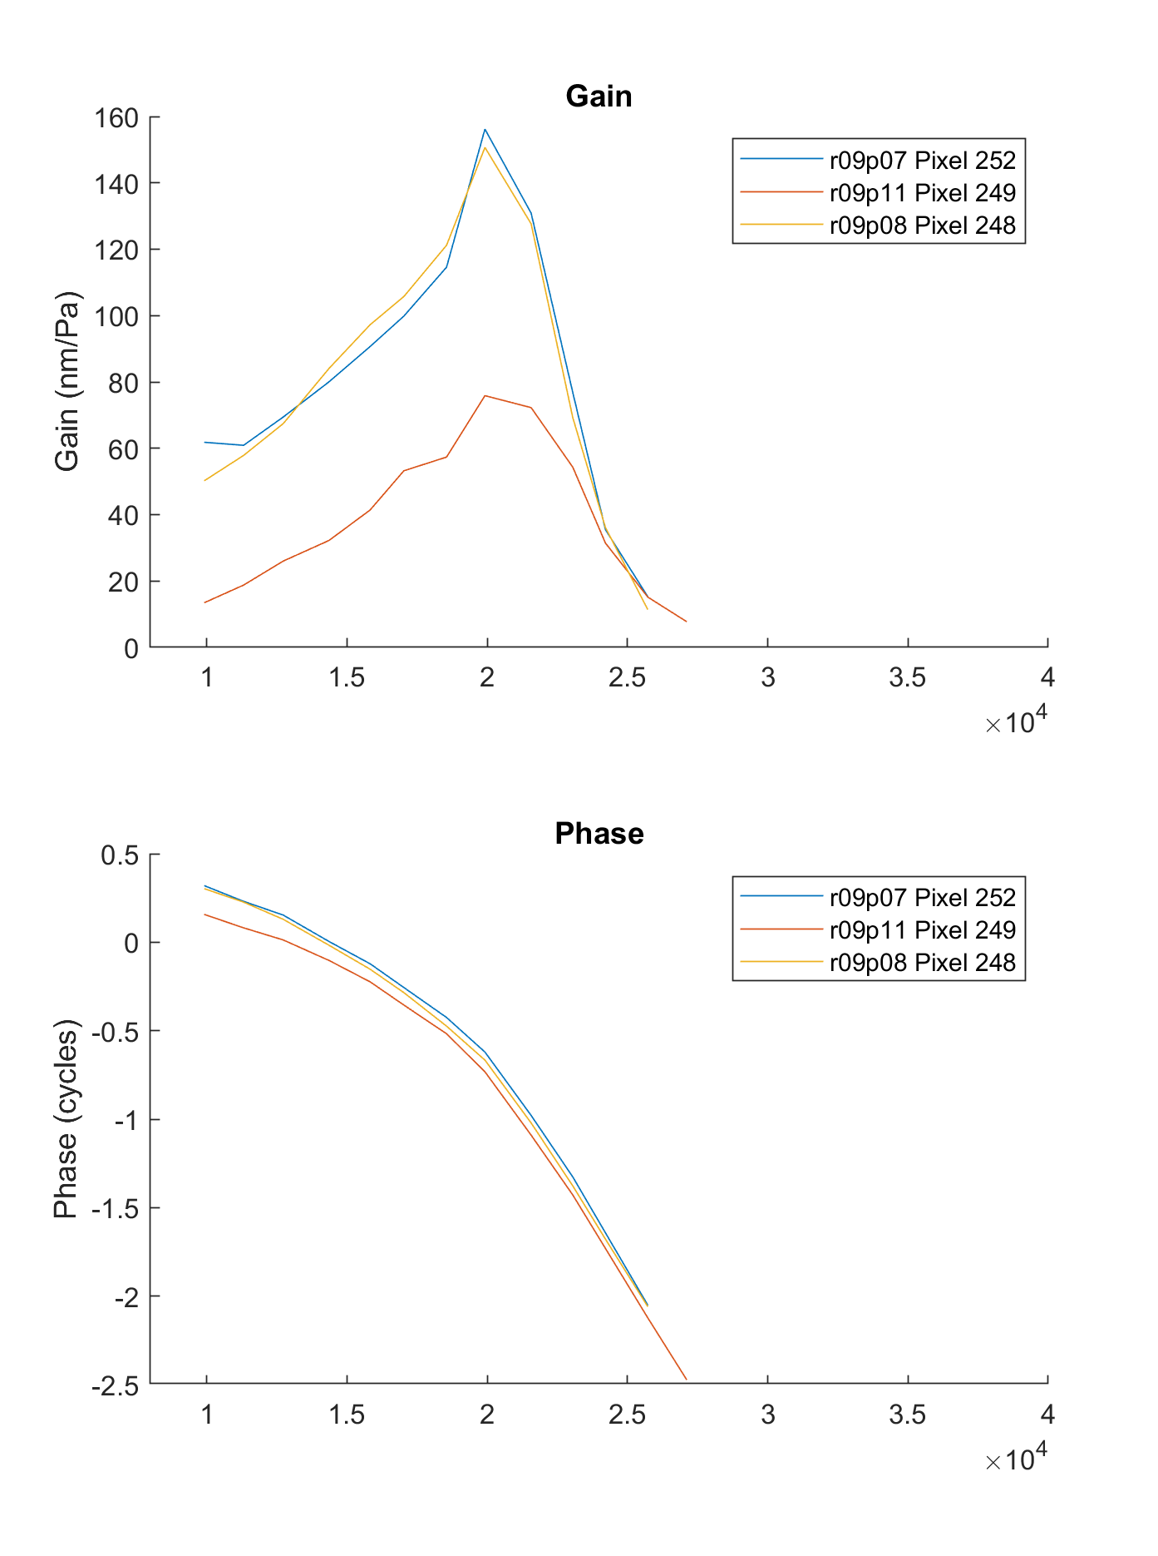
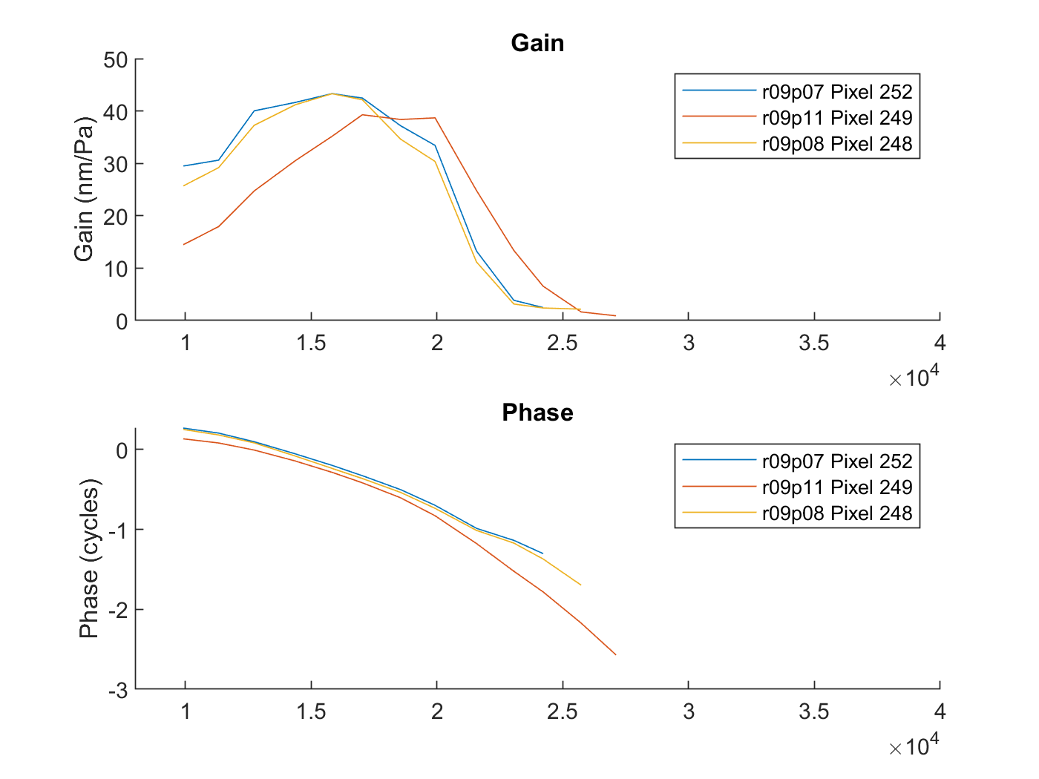
Longitudinal variation (for show)
BM should exhibit travelling wave phase at all SPL. It does 😊
50 dB
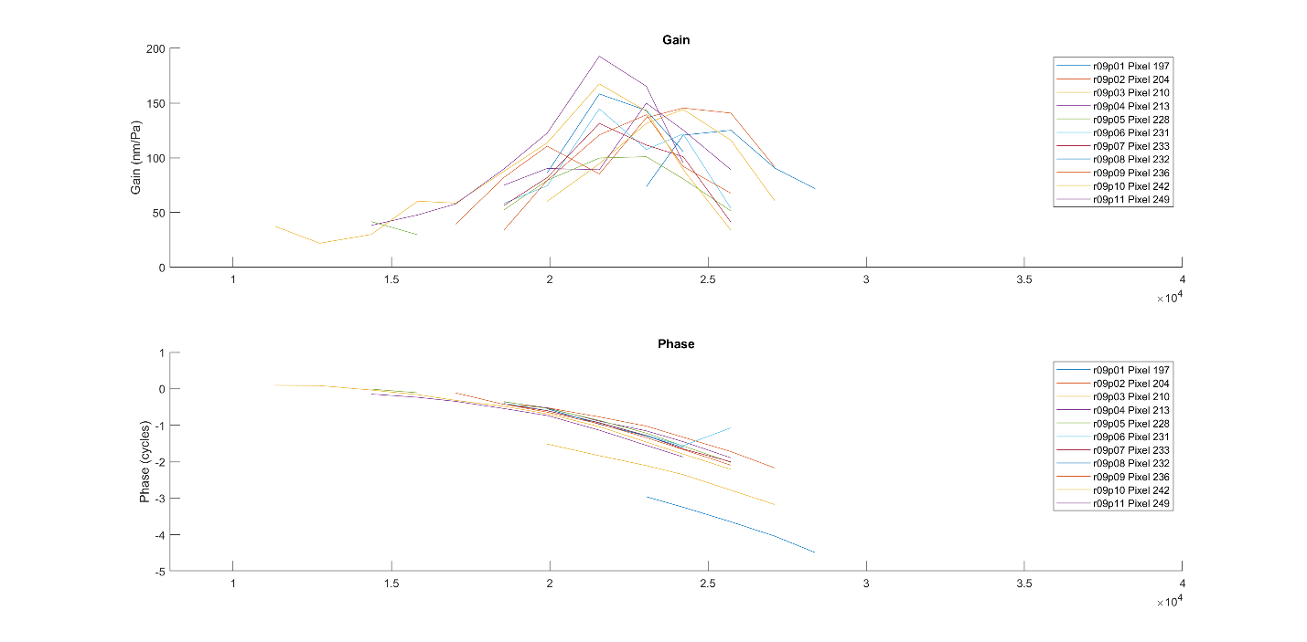
65 dB
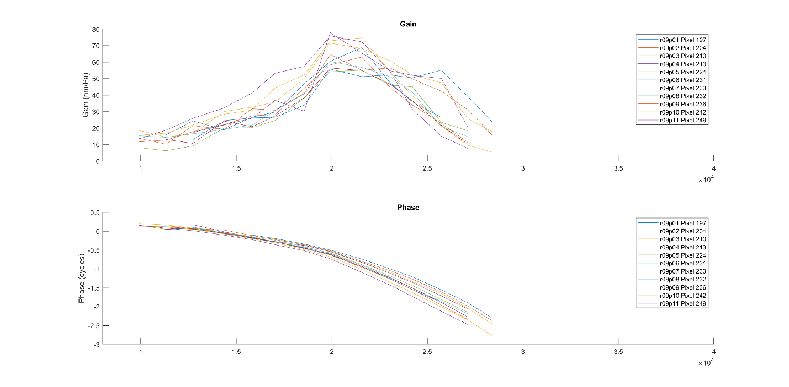
80 dB
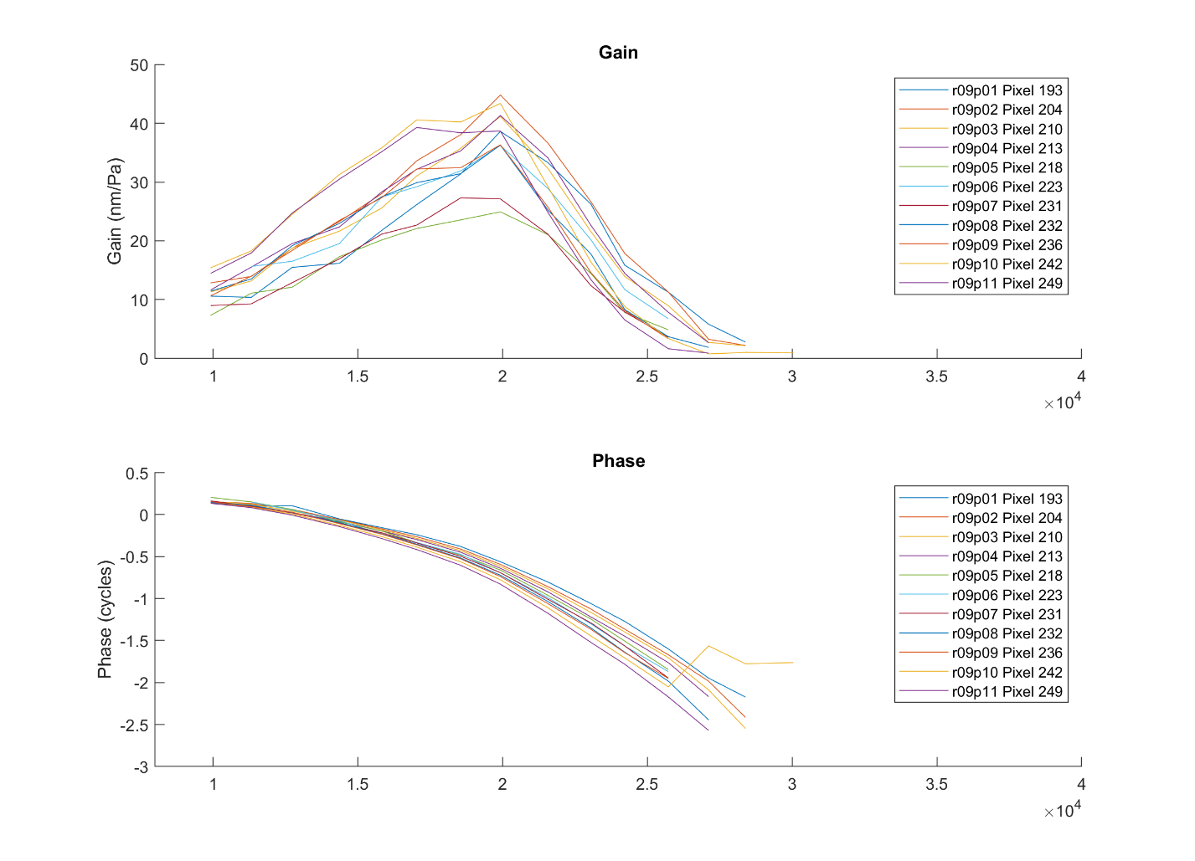
- OHC in same cross-section at different SPL. Positions 1, 2 and 11
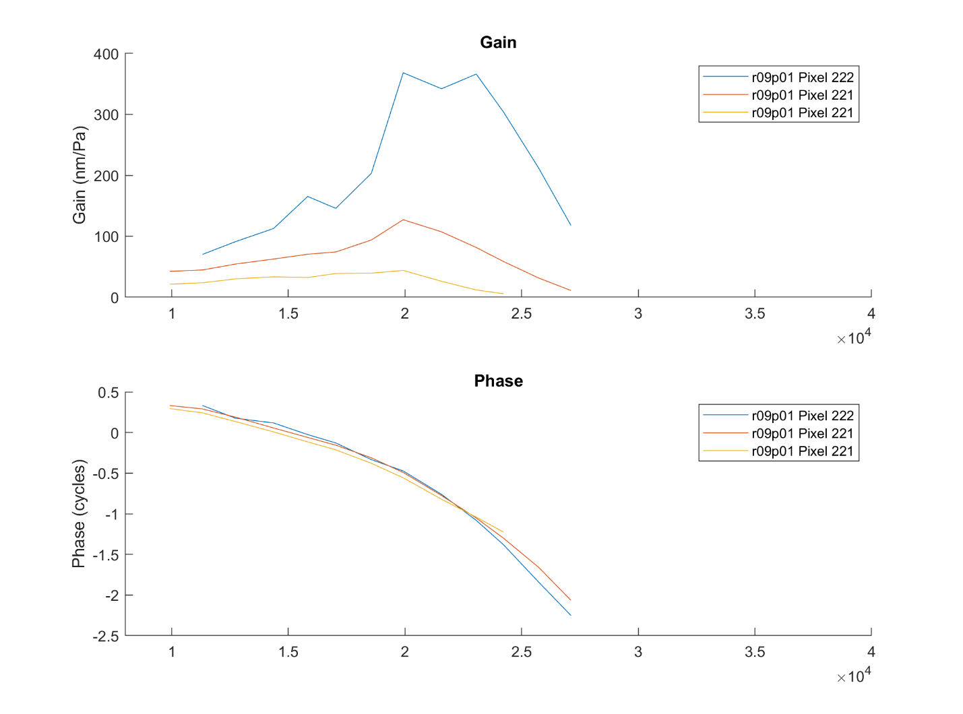
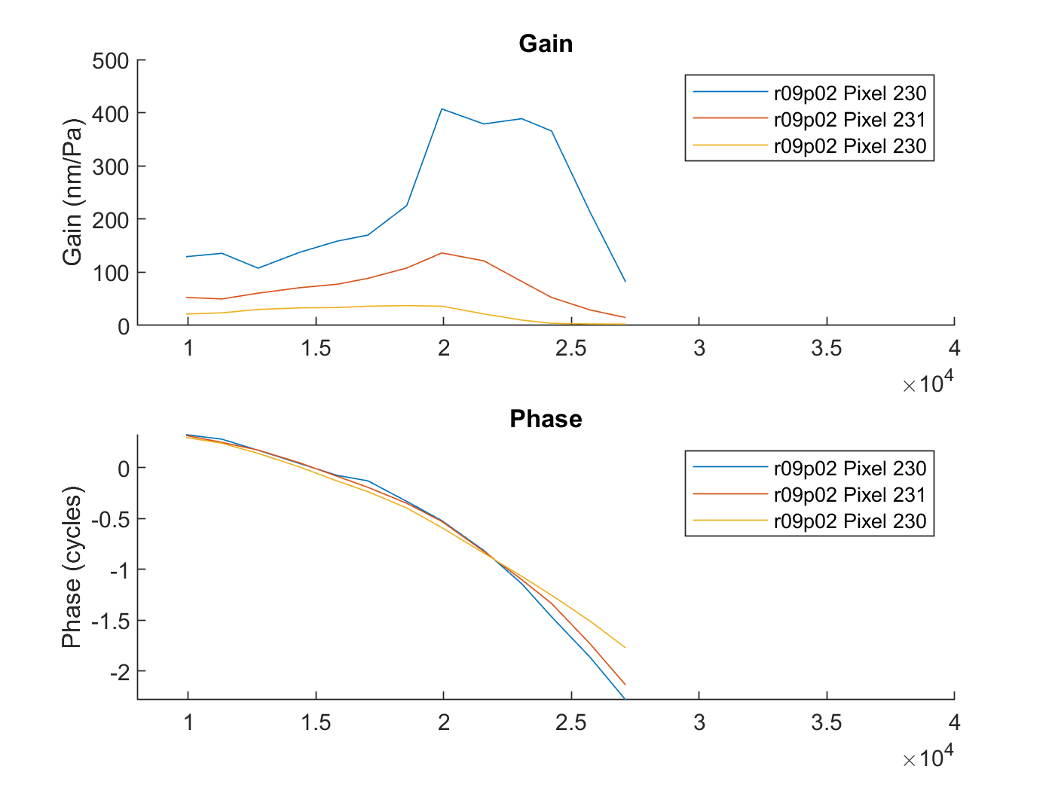

Run 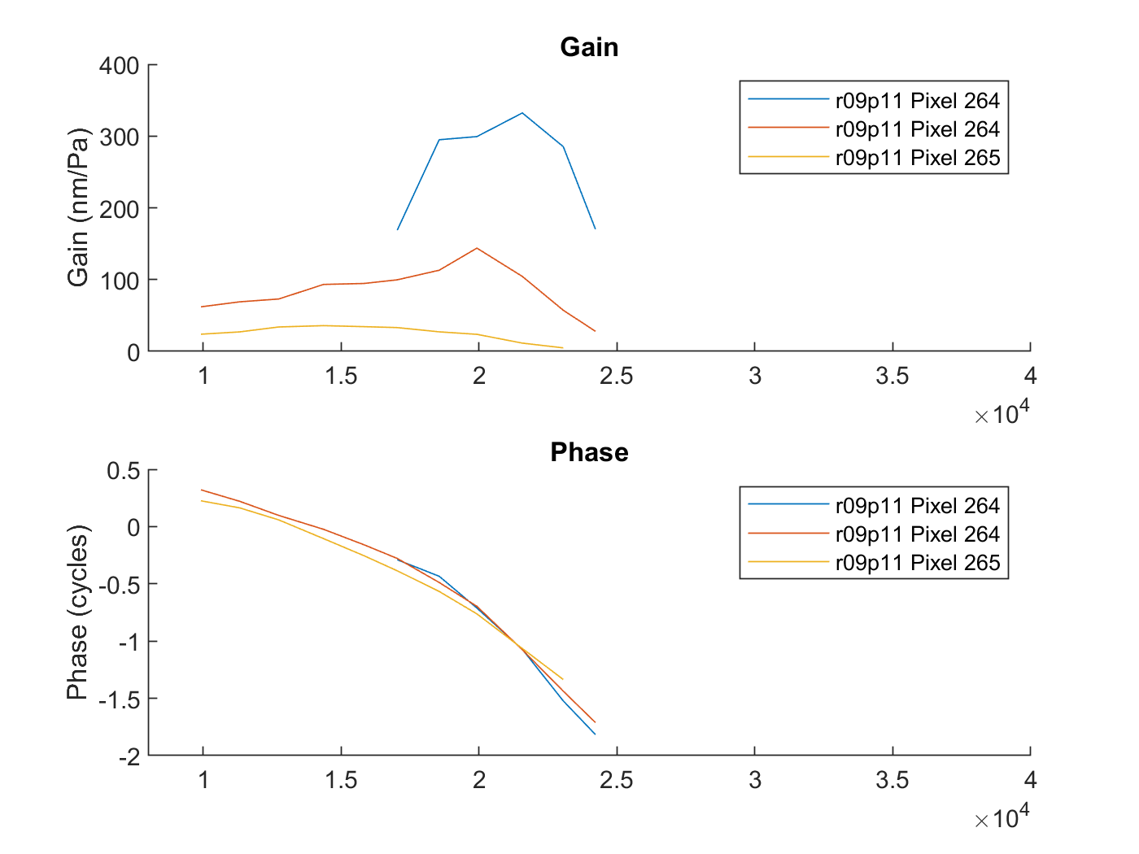
80 dB lags at low freq, leads at high. 50 and 65 in line at low frequency, 50 dB lags at high. All meet at BF.
- OHC – BM phase, 50 65 and 80 dB
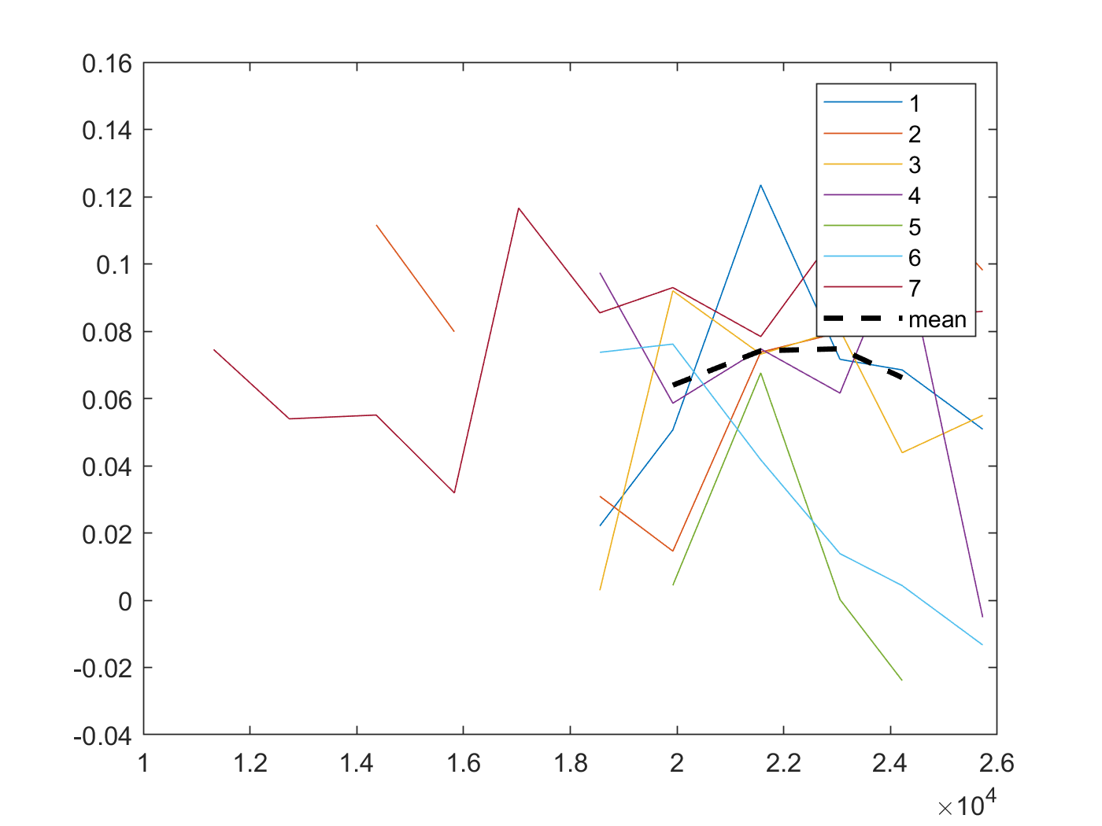
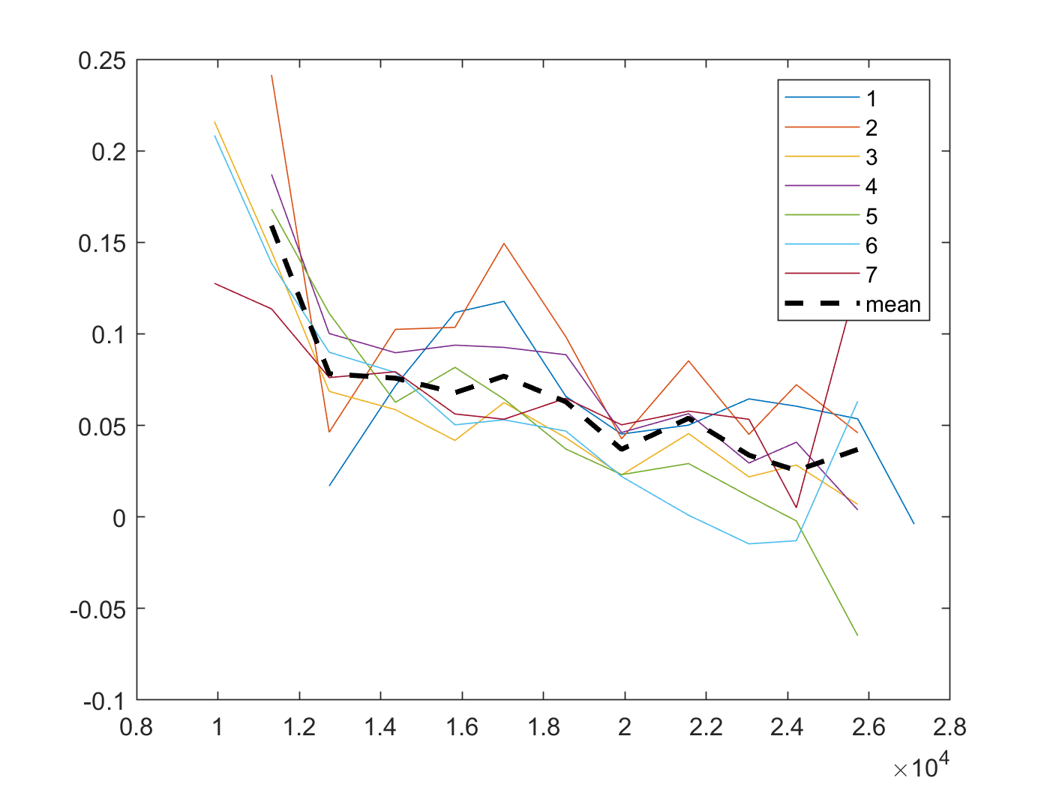

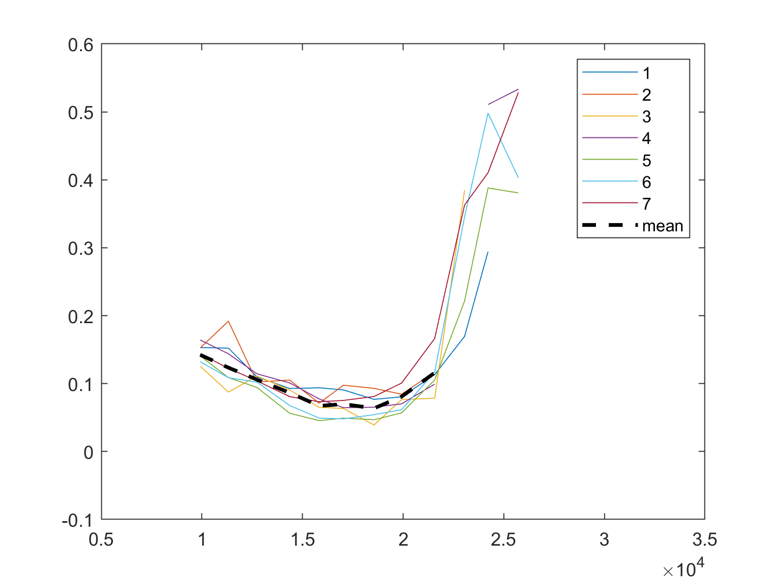
- Qualitative Summary of run 9
We have observed BM and OHC responses at multiple regions of the “OHC region” (including the base of the OHC, or OHC-DC region) across a 160um longitudinal span from the 26 kHz place to the 21.5 kHz place at 50, 65 and 80 dB SPL. We have verified the longitudinal spread via our acquisition method (MOH 2022), our planar approximation method (Frost et al, 2022), as well as by observing the traveling wave phase.
In our acquisition method, we attempted to achieve a 15um longitudinal step size. In verifying with our planar approximation method, we achieved a 16um step size which is remarkably close, validating the acquisition method.
Let’s toot our own horn and look at how mischaracterizing the results are if we look at data along one measurement line, and what is new: look at 50 dB and 65 dB SPL responses. As I always do, I will focus on phase. In all cases, we look at multiple positions to ensure the patterns we see are consistent across length. We will be qualitative first, then quantitative.
At 50 dB SPL and 65 dB SPL we see that the OHC region leads BM at low frequency, then crosses over to lag around 0.8BF. As we move further along the measurement axis away from BM, phase slope decreases (becomes more negative). We know, however, that this also corresponds to moving further apical, so we might attribute this to traveling wave phase.
At 80 dB SPL, we see that OHC leads across frequency, still seeming to “touch” (become in phase with) BM phase at around 0.8BF. Again we see a decrease in this lead as we go further along the measurement axis, probably from a traveling wave shift as we move further apical.
Now, we correct for longitudinal displacement and observe the phase of “aligned” OHC and BM. We look at both the point nearest to and furthest from the BM in our measurements which are 3 and 4 positions from their aligned BM respectively. We see, interestingly, that these two positions have in-line phase, so that the OHC near-base middle/OHC base behave pretty much the same way. We see that at 50, 65 and 80 dB SPL the OHC phase always leads the BM phase across frequency (the 80 dB results are in line with Frost et al, 2022). The lead is largest supra-BF at 80 dB, and similar in size at 50 and 65 dB leading more sub-BF than at 80 dB. This is characteristically different from the comparison at one measurement position.
Observing both these responses AND a comparison of OHC in the same cross-section across SPL, we see that OHC at 50 and 60 dB are in line sub-BF and lead that at 80 dB. They all cross at BF, and then supra-BF 80 dB leads and 50 dB begins to lag 60 and 80 dB.
Let’s try to draw some conclusions from these data:
First off, the OHC near-base middle and OHC base behaving similarly at all SPL at this angle is probably indicative that we have actually measured near base of the OHCs but just across the three OHCs per cross-section (rather than far “into the middle of” the OHCs. Part of why I suggest this is that Dewey, 2021 shows in mouse apex that there is a big shift between the phase along the OHC as you move towards the middle in displacement phase (in mouse apex at his angle, however).
This is sort of a relief to me, because I always worry that we are cherrypicking by accident when we pick the most reflective points in this region. The fact that the points along the scan behave the same way in these characteristic OHC-DC A-Scans is very reassuring.
We reconstructed some OHC motions at 80 dB SPL in Frost MOH 2022, and saw that the lead across frequency was largely due to a longitudinal component leading transverse OHC by ~half a cycle. The size of this contribution at 80 dB should depend only on the angle of measurement, which is a bit more longitudinal than transverse here. We see these same results here.
I am inclined to believe that the longitudinal displacements will be quite similar at all SPL in character (not magnitude), as they are likely caused by fluid motion. Assuming this is the cause of the lead at all SPL, the lead being lower supra-BF at 45 and 60 dB SPL means transverse OHC motion is probably more dominant there, and less dominant sub-BF. Interestingly at all SPL, they seem to be totally in phase at the BF. What this could correspond to is both a decrease in the longitudinal re transverse lead near BF (seen in the reconstructions!) and an increase in the transverse re longitudinal gain (seen in the reconstructions!). This would mean transverse OHC motion might be dominant at BF and similar at all SPL in phase. This is just a hypothesis, that of course must be tested more rigorously.
Observing the OHC-BM phase curves we see some difference between different positions along the Basilar membrane. Of course, there must be some natural variation so it’s hard to say exactly why this might be, but the difference is at most ~10 degrees from the mean.

- Run 13 – 51 degree angle. 11 positions spaced ~16um apart in l. OHC-RL region. Base-Apex as position increases. Pos 1: 26 kHz, Pos 11: 21.5 kHz
Here we are starting at more-or-less the same longitudinal location, but further medial so that we can capture the RL region. This means that the BM vibrations are much smaller in magnitude here, so we will instead compare to our BM measurements from run 9 (same angle, different radial location). This is fine as they should have the same phase, which is what we take interest in.
- BM and RL within one cross-section, or “aligned” (RL BLUE, BM RED)
I eventually just plotted phases…
Position 1 50, 65, 80 dB
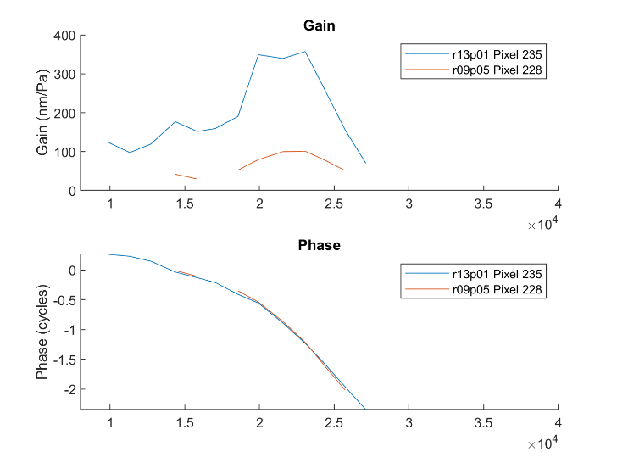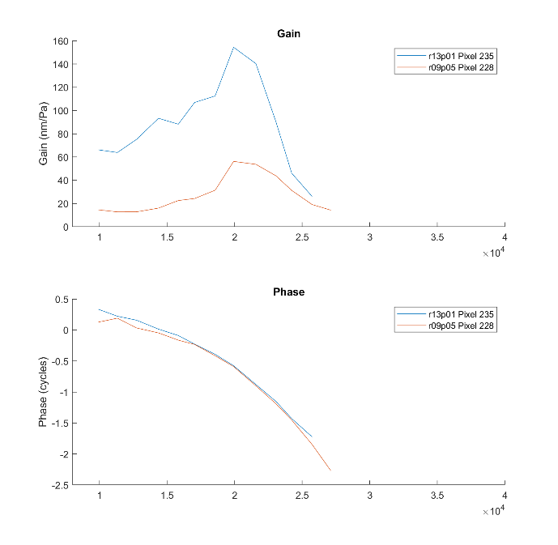
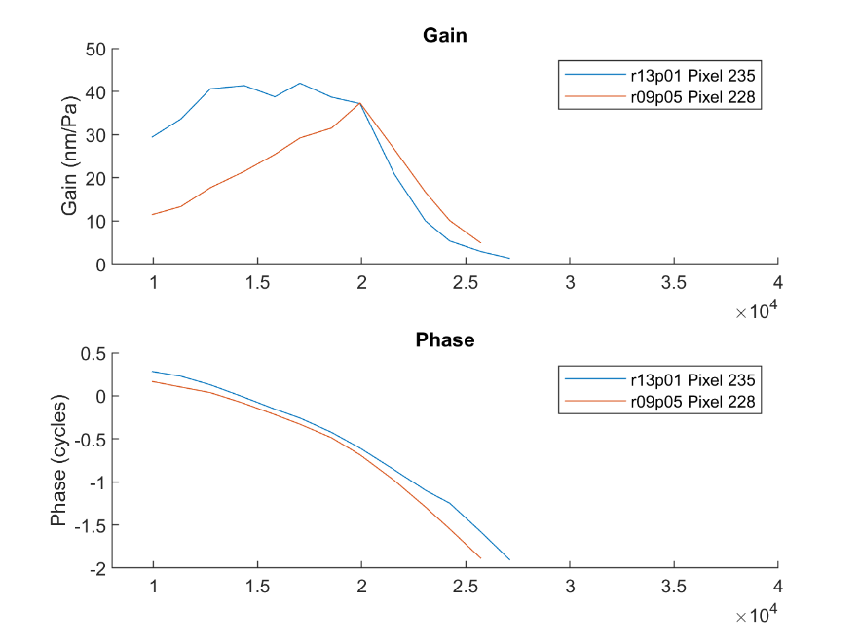

Position 2 50, 65, 80 dB
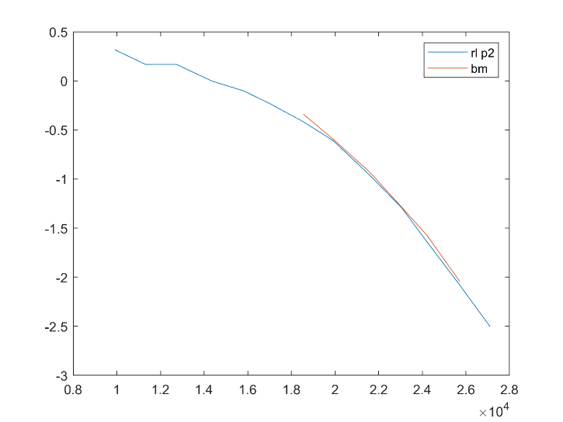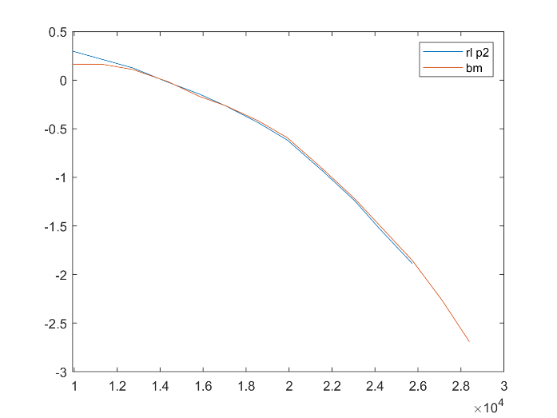
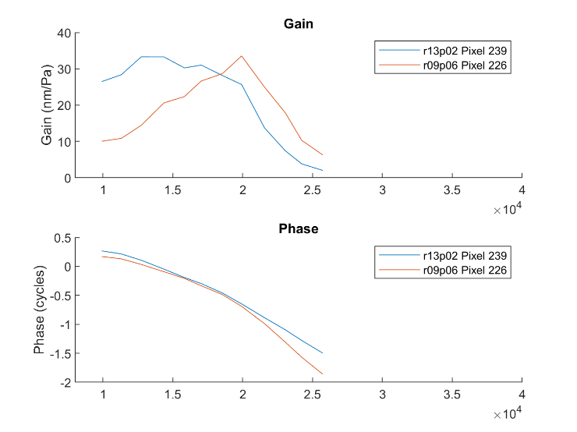
Position 3
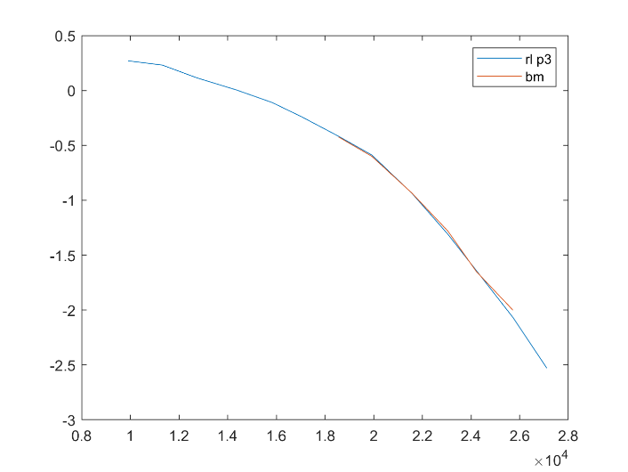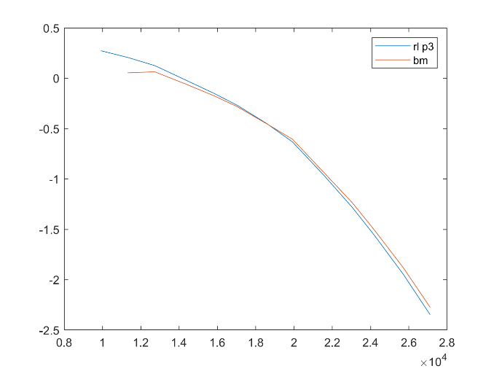
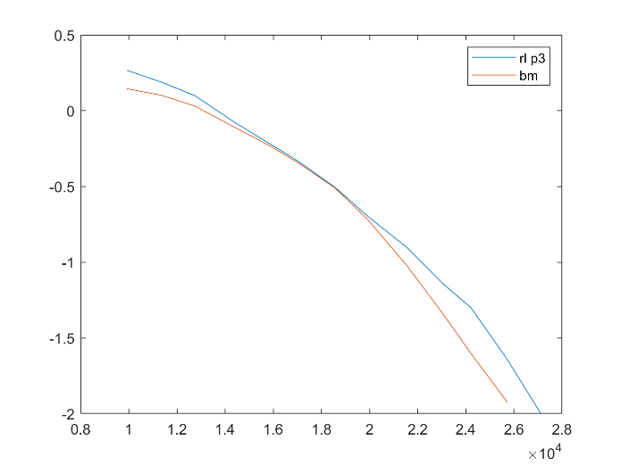
Position 5
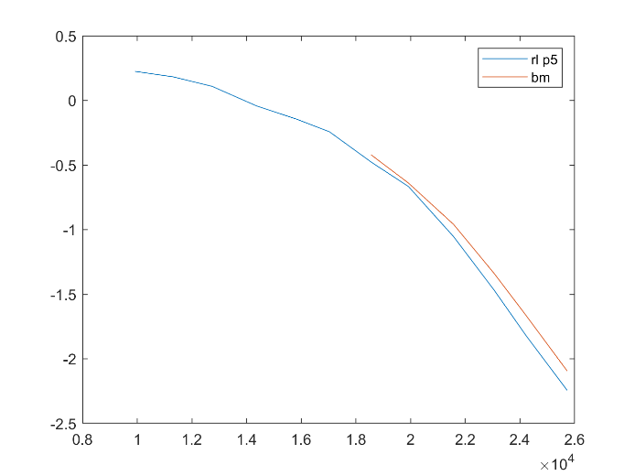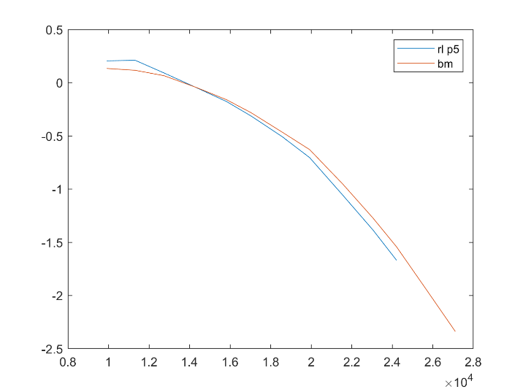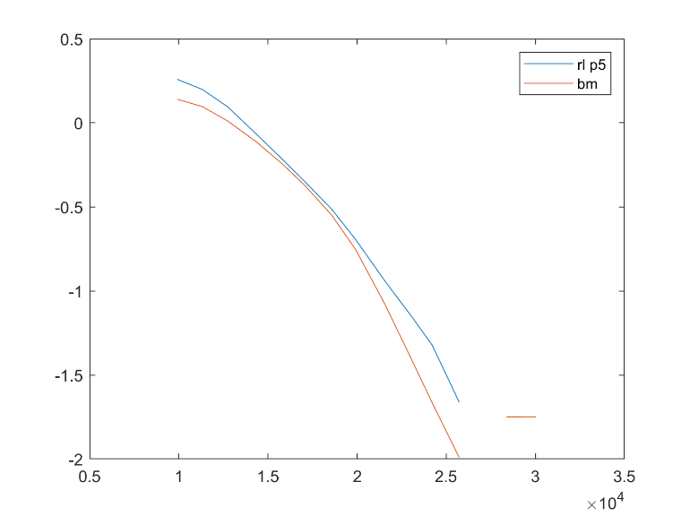

Position 7
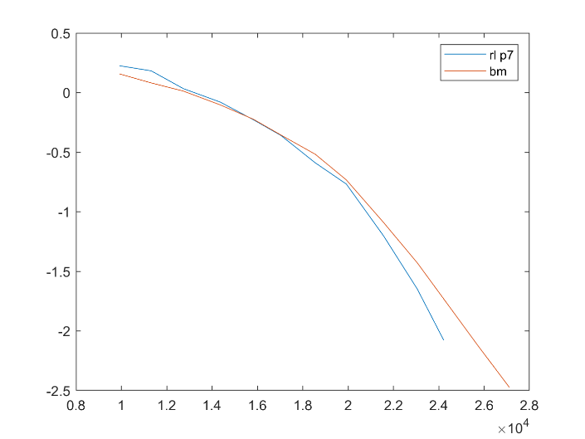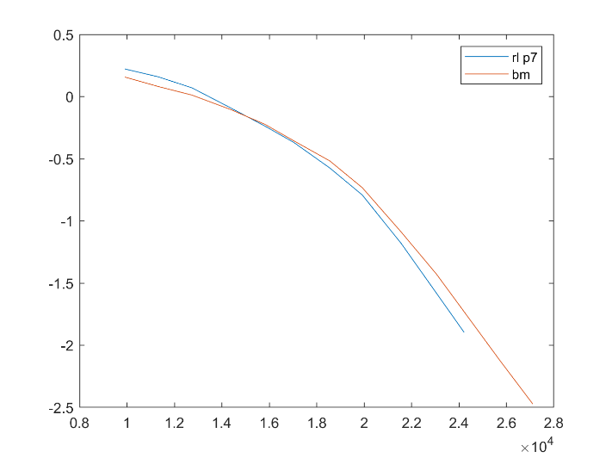
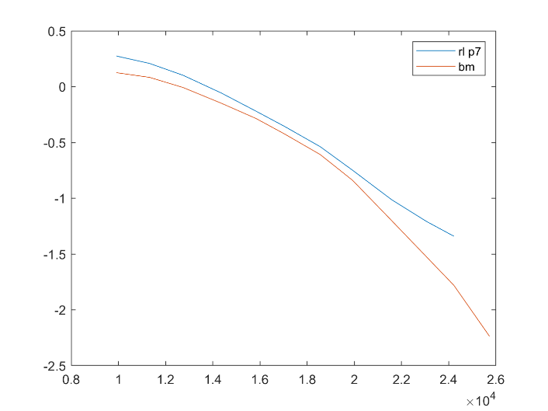
- RL and OHC-DC in same cross-section (RL blue, OHC-DC red)
This is the most interesting part, so I will present all of the present data.
Position 1 50, 65, 80 dB
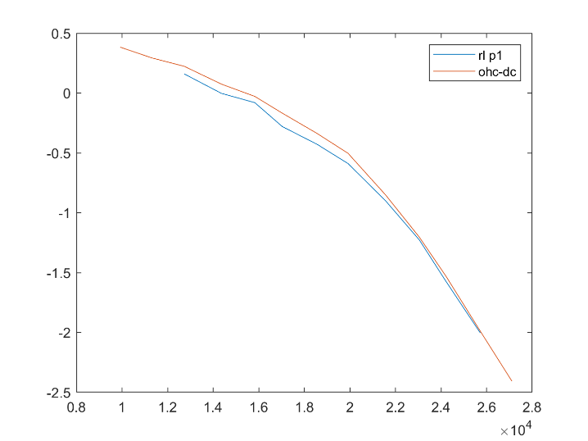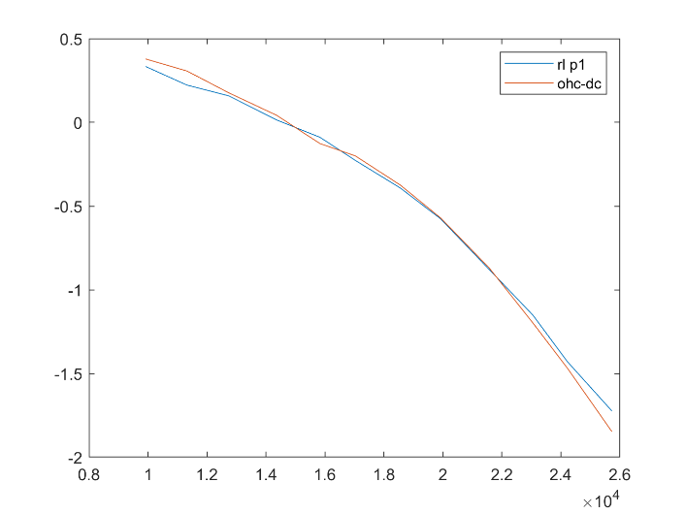
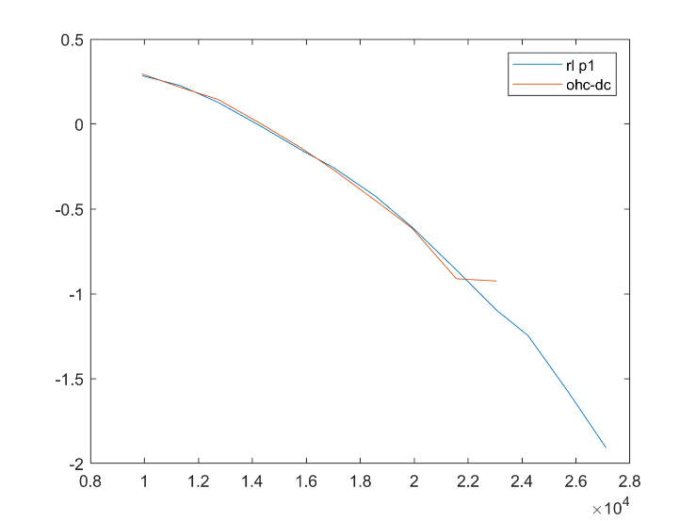
Position 2
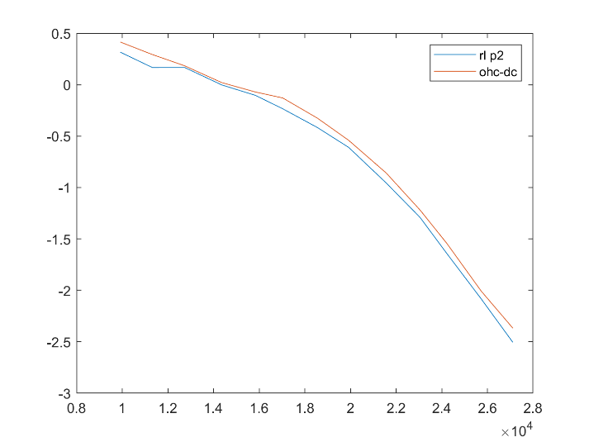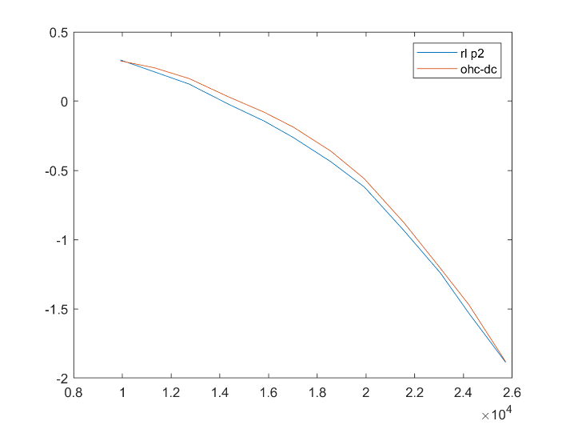
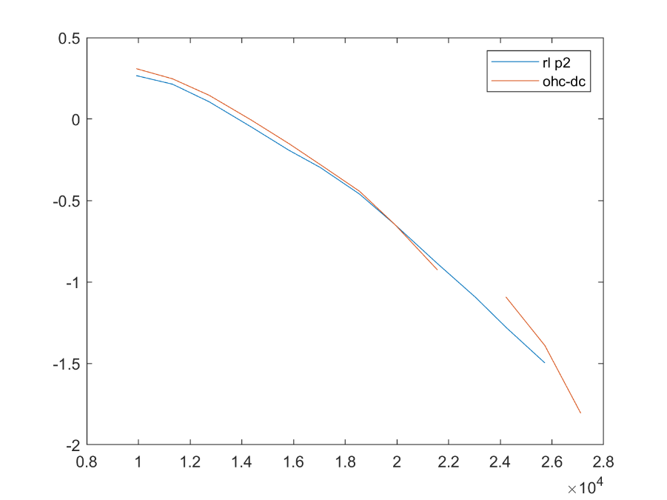

Position 3
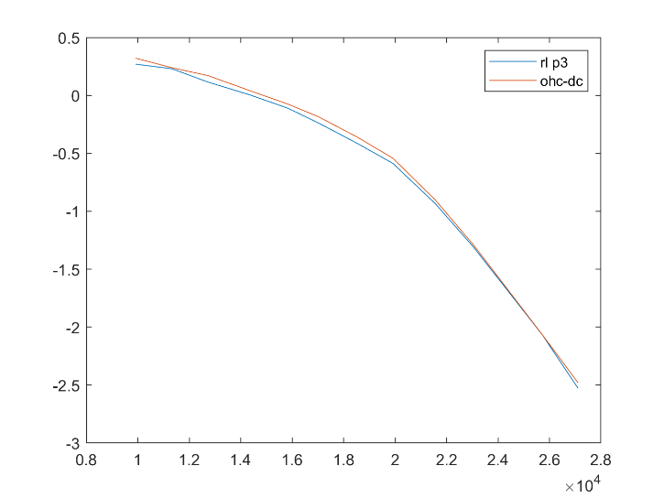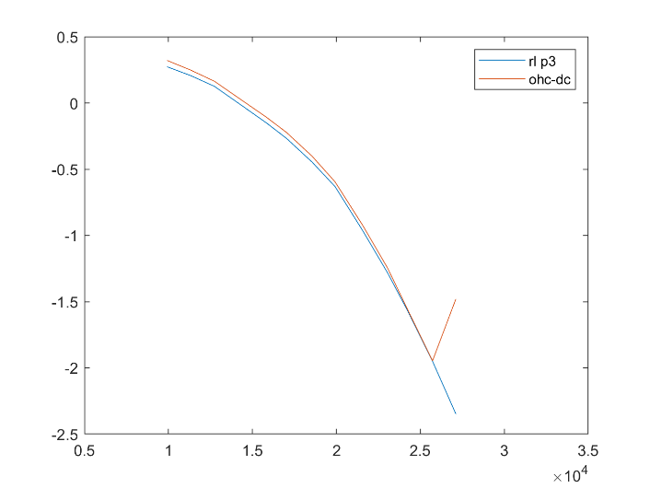
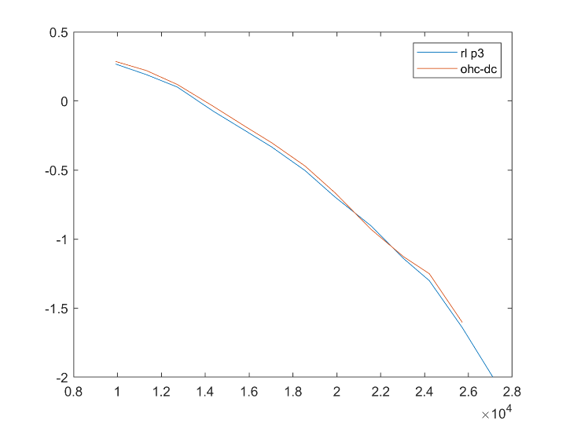
Position 4
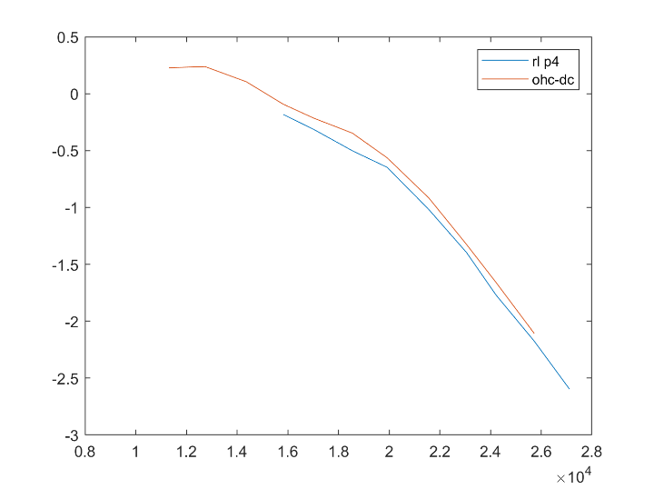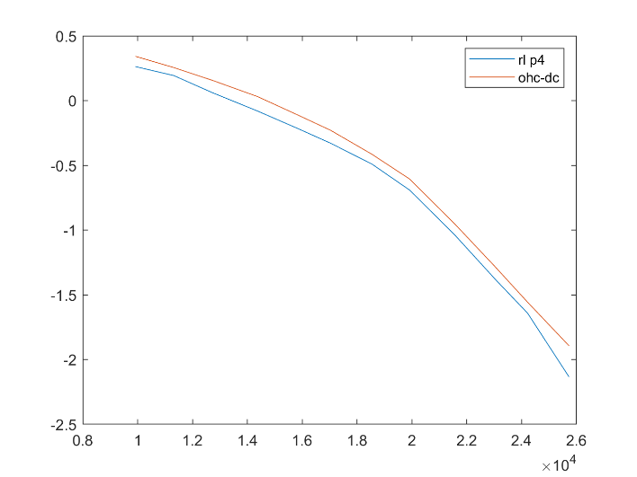
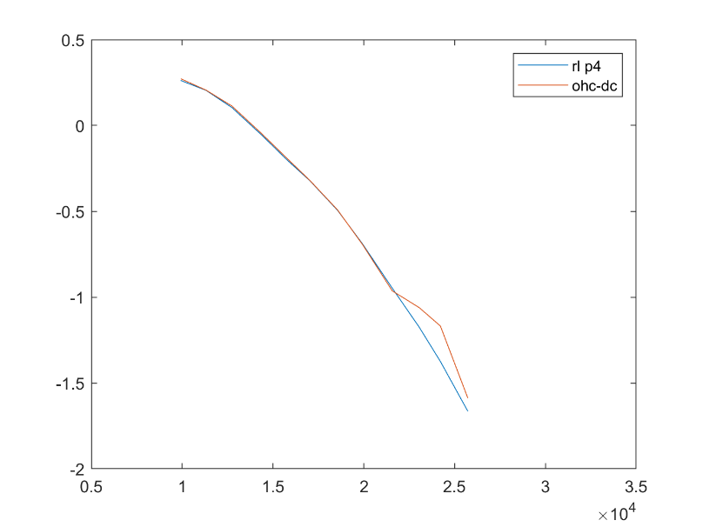
Position 5
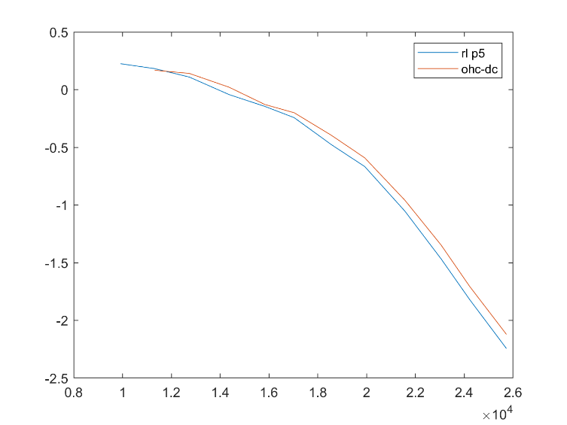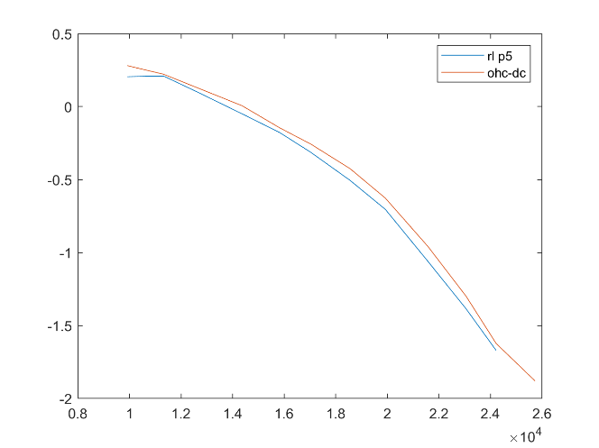
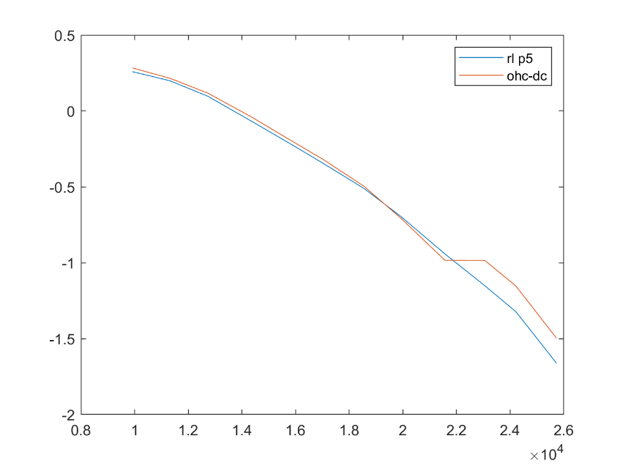
Position 6
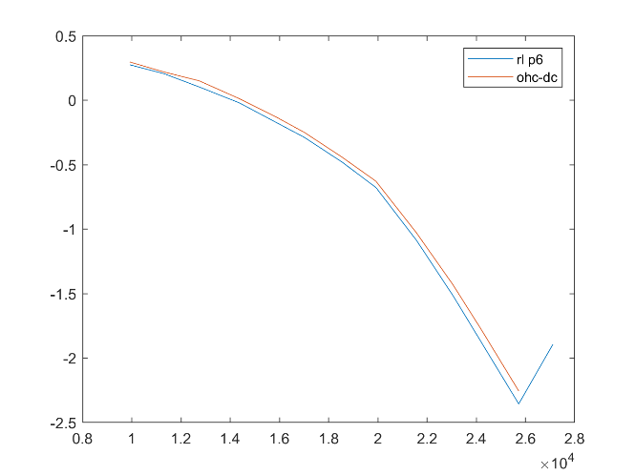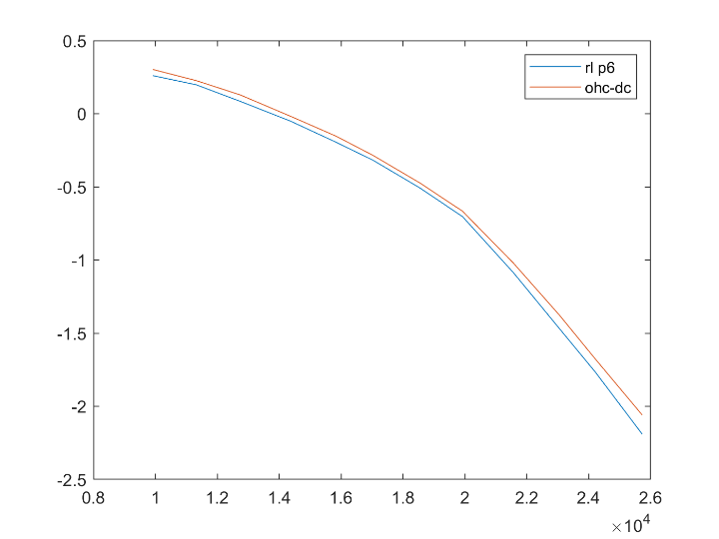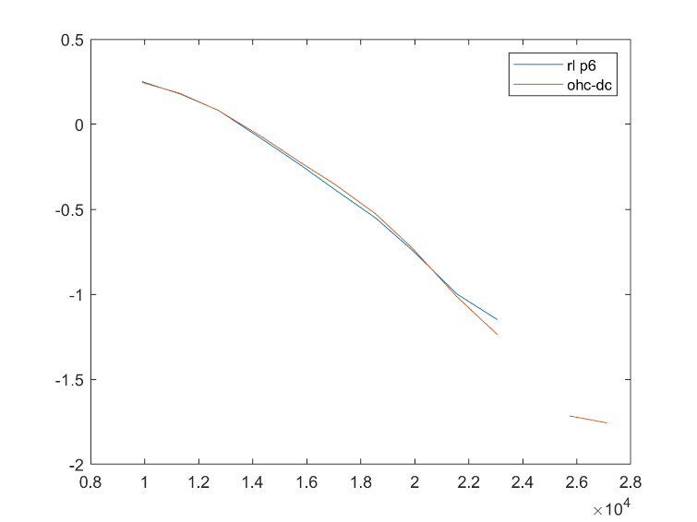
Position 7
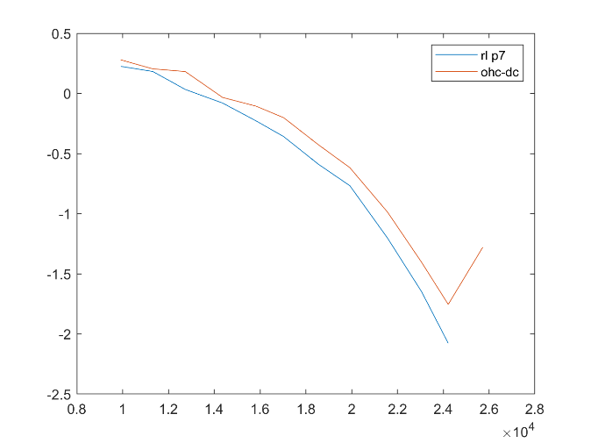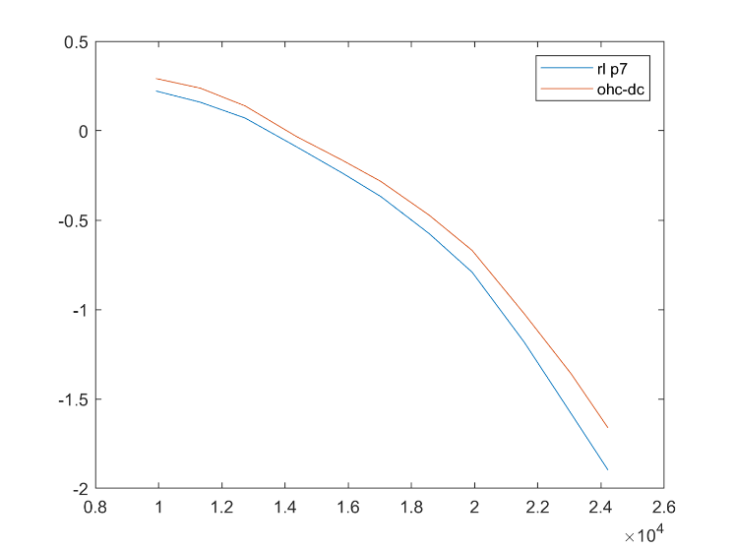
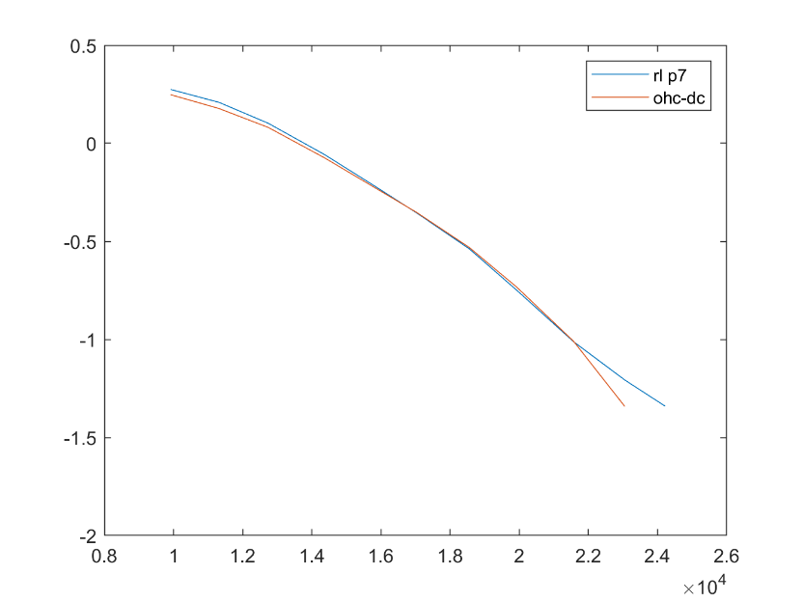
- RL-OHC phase 50, 65, 80 dB
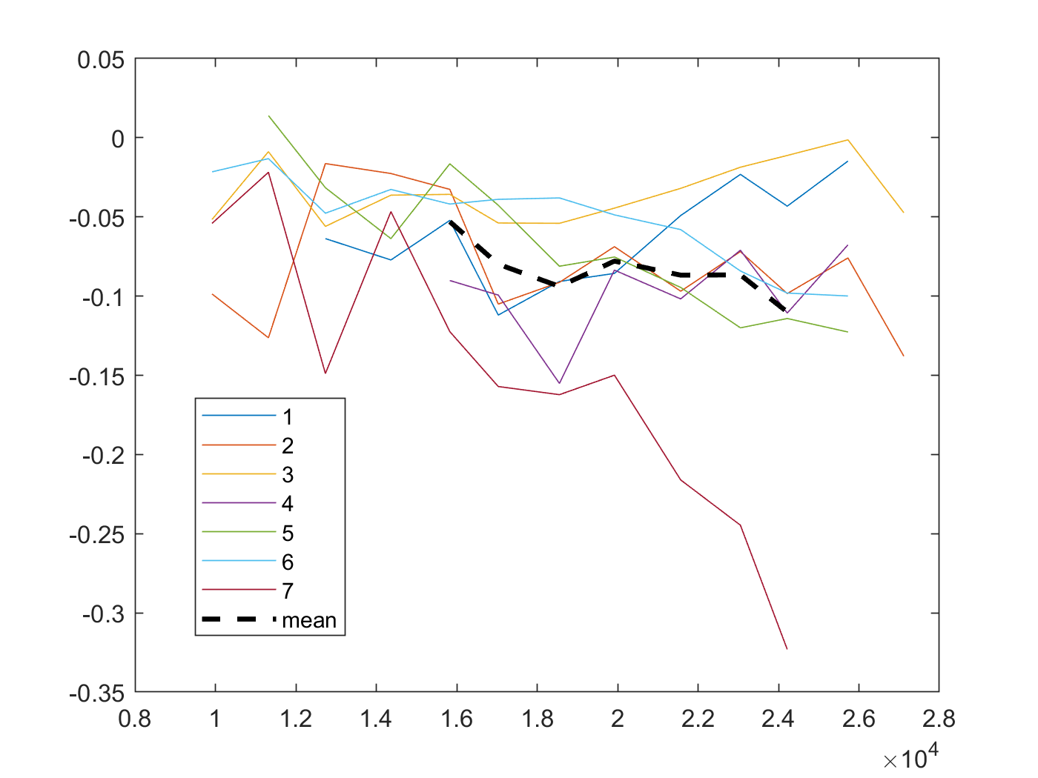
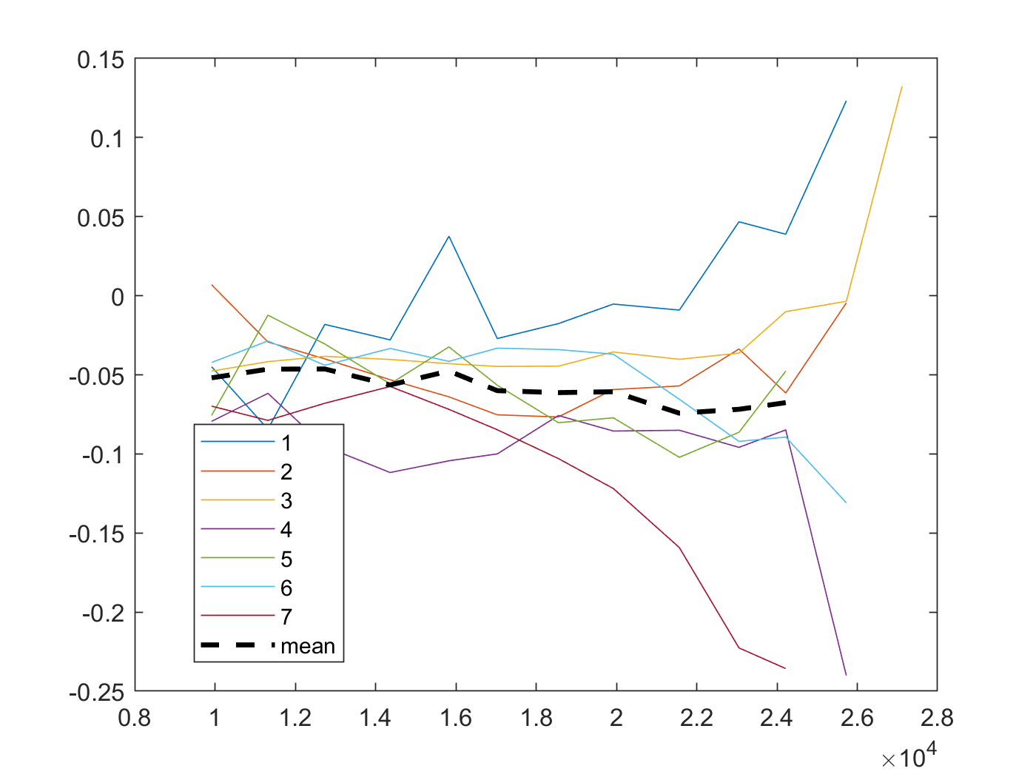
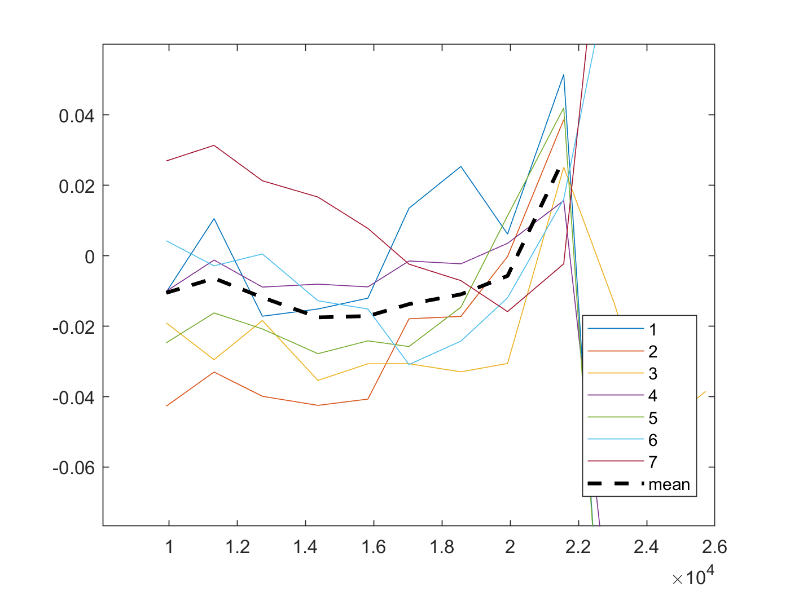
- Qualitative summary of run 13 and run 13 re 9
First, focusing on the RL vs BM comparisons, we see interesting differences in behavior across SPL when we correct for longitudinal displacement. At most points at 50 and 65 dB we see almost no difference between RL and BM. However, where we do see a difference, it is a high-frequency lead of BM re RL. This is similar to what we see in Ren’s data across SPL at high frequencies. However at low frequencies it is different – Ren sees a lead of RL re BM at low frequencies whereas we are seeing no difference.
At 80 dB, however, we see a strange change at all positions: an across-frequency lead of RL re BM! This is very similar to what we see in correcting the OHC-DC region for displacement, so are OHC-DC and RL regions behaving the same as one another?
No. Dewey sees that OHC-DC and RL displacements are almost always out of phase by ~.5 cycles across frequency and SPL, with the difference decreasing slightly as SPL increases. We align OHC-DC and RL measurements and plot the two phases with one another. We should be careful to consider the effect the angle might have here.
We see that at lower SPLs, OHC-DC leads RL at almost every position, on average by ~20 degrees. Sometimes this lead diminishes at 65 dB SPL, but almost always at 80 dB SPL the two seem to be more-or-less in phase. That is, at our measurement angle we see an OHC-DC lead re RL that decreases as SPL increases.
We see far less of a phase difference than Dewey, but two aspects of our measurement angle are different – 1, we have a large longitudinal component that he does not likely have; 2, he measures with a large radial component, with a measurement angle parallel to the length of the OHC. This is likely to show the effects of electromotility more directly, but it obscures transverse-longitudinal motion components.
In our B-Scans, the OHCs appear to lie at a 30 degree angle to the transverse direction, so this OHC-length-axis component has a projection of ½ magnitude onto the transverse axis. Our angle has ~0.6 component in the transverse direction, leading to ~0.25 of this component being represented onto our axis of measurement. Then, who knows what’s bigger than what! This is all to say that there is a LOT obscuring this axis of motion.
Is what we see reasonable/expectable? I would say yes – our OHC-DC region measurements at 80 dB SPL are in line with our reconstructions, and at lower SPL seem to imply that transverse motion is more dominant at 50 and 65 dB than at 80 dB. This is what one would expect.
As for RL, we see at high SPL they move almost the same as OHC-DC and (probably) would have a similar reconstruction. This could mean that the gross transverse motion of the OCC would be contributing to OHC transverse motion more than electromotility, which is expected. However, at lower SPLs we see that RL moves very similarly to OHCs with only a ~constant phase difference. This indicates that here the transverse component of motion is impacted more by electromotility at lower SPLs.
I am very upset that we could not reconstruct any motion from the RL region. Maybe next time!
- Run 26 – 41 degree angle. 11 positions spaced ~14um apart in l. OHC-DC region. Apex-Base as position increases.
The angle here was too similar and the position was too apical so we didn’t get good enough data to attempt reconstruction. Unfortunate! But, here are some curves of OHC-DC vs BM that look very similar to what we saw above, if anyone cares…
- OHC-BM, 65 and 80 dB SPL


